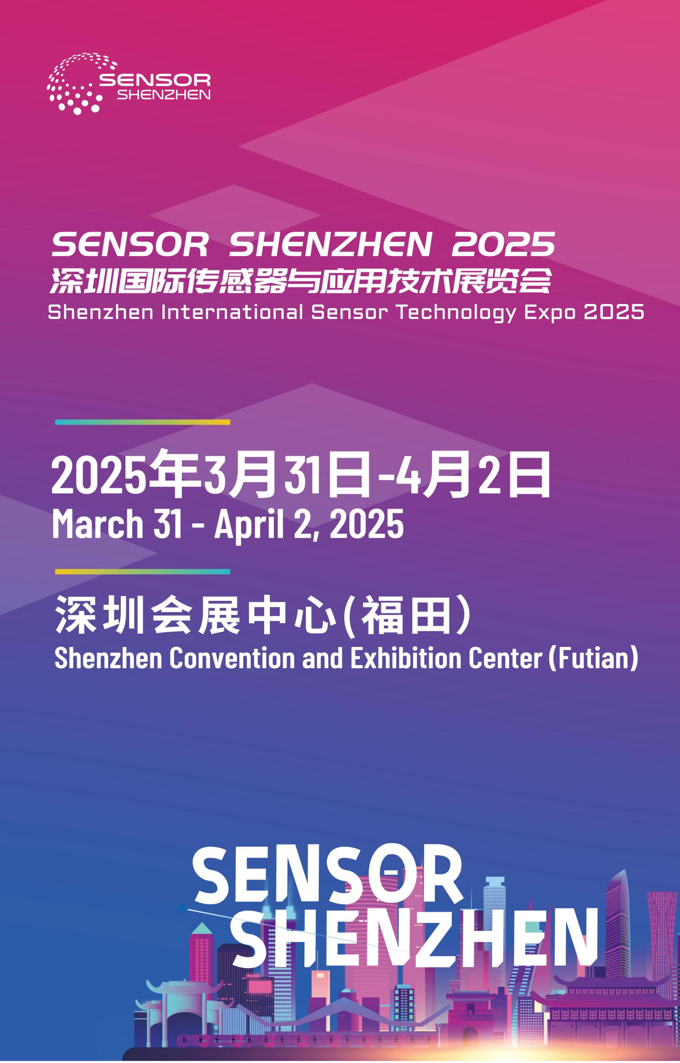

**EXHIBITOR MANUAL**

**31 March-2 April 2025**

**Shenzhen Convention & Exhibition Center, Hall 7&8**

Welcome to the Sensor Shenzhen 2025

We are pleased to compile this Exhibitor Manual to assist you in your preparation for the exhibition. Kindly study the content carefully and please feel free to contact us should you require further assistance or clarification.

To ensure that your orders are processed on time, we would appreciate if you could submit the forms by the stipulated deadline. Please note that all late orders will incur additional charges.

For further reference, please retain a printout of each form submitted to check against invoices billed for your orders.

We would like to highlight the following point to you. Exhibitors are only authorized to exhibit products for which they are manufacturer, agent, distributor or dealer. In case of conflict, the Organizer will try to assist to resolve the matter amicably and fairly for all parties concerned.

We wish you all the best at **Sensor Shenzhen 2025**.

Yours sincerely,

Sensors and IoT Industry Association

|  |
| --- |
| **Shanghai office** |
| 503F, Building 1, 333 Huangqing Road, Jiading district, Shanghai, China 201800 |
| Tel：(86) 21 6990 0833 |
|  |

**Contents**

**Please click on the link jump to the related page.**

**FORMS DEADLINE CHECKLIST (STANDARD BOOTH & UPGRADED STANDARD BOOTH)**

**FORMS DEADLINE CHECKLIST (RAW SPACE ONLY)**

**USEFUL CONTACT DETAILS**

**LOCATION OF SHENZHEN CONVENTION & EXHIBITION CENTER**

**SCHEDUAL OF CONSTRUCTION PERIOD**

**1. GENERAL INFORMATION**

1.1 EXHIBITION NAME

1.2 VENUE

1.3 DATES AND OPENING HOURS

[1.4 ORGANIZER](#_1.5___     组委会)

1.5 SECURITY

1.6 ACCOMMODATION

1.7 ADMISSION

[(a) Exhibitors](#_(a)_参展商)

[(b) Visitors](#_(b)_观众)

[(c) Contractors](#_(c)_搭建商)

1.8 COMMUNICATION

1.9 BUSINESS CENTRE

1.10 TRANSLATION OF PROMOTIONAL MATERIALS

1.11 EXHIBITION HALL SPECIFICATIONS

1.12 BOOTH SPECIFICATIONS

(a) Standard Booth

(b) Upgrade Booth

1.13 CONFIGURATION

(a) Standard Booth

(b) Upgrade Booth

1.14 CAFETERIA

**2. RULES AND REGULATIONS**

2.1 OBSERVATION OF RULES AND REGULATIONS

2.2 CHINESE FAIRS AUTHORITY RULING

2.3 MANNING AND CONDUCT OF BOOTH OPERATIONS

2.4 IN-HALL FREIGHT HANDLING

2.5 CUSTOMS CLEARANCE

[2.6 LOCAL DELIVERY](#_2.7___    本地送货)

2.7 PAYMENT FOR SPACE OR SHELL SCHEME BOOTH

2.8 STORAGE AND WASTE MATERIALS

2.9 DELIVERY AND REMOVAL OF EXHIBITS

2.10 DOCUMENTS CENSORSHIP

2.11 PUBLIC AUDIO

2.12 USE OF SPREADER PLATES

2.13 INDUSTRIAL GAS

2.14 BOOTH CLEANING

2.15 PRESENTATION, DEMONSTRATIONS OF WORKING EXHIBITS

2.16 ON-SITE VOLUME

2.17 RENTAL FURNITURE

2.18 BOOTH-BUILDING REGULATIONS

[2.19 ELECTRICAL SERVICES](#_2.20___  电力装置)

2.20 COMPRESSED AIR

2.21 AIR-CONDITIONING

2.22 PHOTOGRAPHY

2.23 FIRE PRECAUTION

[2.24 FORCE MAJEURE](#_2.24___  责任和风险)

[2.25 DILAPIDATION](#_2.25___  展馆损毁)

[2.26 AUTHORITY ON THE PREMISES](#_2.26___  展馆拥有权)

[2.27 MOVING-OUT](#_2.27___  撤馆须知)

**SERVICE ORDER FORMS**

|  |  |
| --- | --- |
| 1 | FASCIA NAME FOR STANDARD BOOTH |
| 2 | FURNITURE (RENTAL) |
| 3 | SPECIAL BOOTH FEE AND OTHER SERVICE APPLICATION |
| 4 | ELECTRICAL SERVICE (RENTAL) |
| 5 | COMPRESSED AIR /WATER SUPPLY AND DRAINAGE (RENTAL) |
| 6 | TELEPHONE/NETWORK (RENTAL) |
| 7 | CONSTRUCTION APPLICATION FORM |
| 8 | ENTRY WORK SAFETY COMMITMENT LETTER |
| 9 | PRECAUTIONS FOR FIRE PROTECTION AND CONSTRUCTION SAFETY |
| 10 | SELF INSPECTION FORM FOR BOOTH CONSTRUCTION COMPLETION |
| 11 | LETTER OF RESPONSIBILITY FOR EPIDEMIC PREVENTION |
| 12 | COMMITMENT LETTER FOR VIDEO PLAYBACK MANAGEMENT AND VOLUME CONTROL |
| 13 | EXHIBITOR BADGE APPLICATION |
| 14 | HOTEL Accommodation |
| 15 | FREIGHT INSTRUCTIONS |
| 16 | EXHIBITION INSURANCE |
| 17 | Conference ROOM RESERVATION |

# 

# FORMS DEADLINE CHECKLIST

|  |  |  |  |
| --- | --- | --- | --- |
| **DEADLINE** | **FORM** | **Form content** | **Note** |
| **2025-2-28** | **Form-1** | **Company Fascia** | **Standard Booth Must Submit** |
| **2025-2-28** | **Form-2** | **Standard Booth Furniture Rental** | **Standard Booth Must Submit** |
| **2025-2-28** | **Form-3** | **Special Booth Fee and other Service Application** | **Special Booth Must Submit** |
| **2025-2-28** | **Form-4** | **Special Booth Electricity Application** | **Special Booth Must Submit** |
| **2025-2-28** | **Form-5** | **Special Booth Air Compressor and Water Application** | **Require to Fill out and Submit** |
| **2025-2-28** | **Form-6** | **Internet and phone line Application** | **Require to Fill out and Submit** |
| **2025-2-28** | **Form-7** | **Special Booth Construction Application Form** | **Special Booth Must Submit** |
| **2025-2-28** | **Form-8-1** | **Commitment letter for safety of Move-in operation of Shenzhen Convention and Exhibition Center** | **Special Booth Must Submit** |
| **2025-2-28** | **Form-8-2** | **Event, Activity Fire and Construction Safety Constructor Notification Sheet** | **Special Booth Must Submit** |
| **2025-2-28** | **Form-9** | **Self inspection and Self inspection Form for Completion of Booth Construction** | **Special Booth Must Submit** |
| **2025-2-28** | **Form-10** | **Commitment Letter for Video Playback Management and Volume Control** | **Special Booth Must Submit** |
| **2025-2-28** | **Form-11** | **Exhibitor Badge Application** | **All exhibitors must submit** |
| **2025-2-28** | **Form-12** | **Room Accommodation** | **Require to Fill out and Submit** |
| **2025-2-28** | **Form-13** | **Customs Clearance and Shipping** | **Require to Fill out and Submit** |
| **2025-2-28** | **Form-14** | **Certificate of Exhibition Liability Insurance** | **Special Booth Must Submit** |
| **2025-2-28** | **Form-15** | **Conference Room Booking** | **Require to Fill out and Submit** |

**Note：**

1. ***“Form2、Form3、Form4、Form5、Form6、Form7、Form8-1/8-2、Form9、Form10”Please log into Official Venue Constructor Website to submit（<http://zhan.zzxes.com.cn> ）before deadline（New user need to sign on first）；***
2. ***“Form1、Form11、Form15”please fill out and send it back to organizer（[expo@sistiot.com](mailto:expo@sistiot.com)） before deadline;***
3. ***“Form12”please log into <https://dwz.cn/08HKqeCr> and submit before deadline；***
4. ***“Form14”please log into [www.yzerm.com](http://www.yzerm.com)and submit before deadline；***

**USEFUL CONTACT DETAILS**

**ORGANIZER：**

Sensors and IoT Industry Association

Silicon Sensing Technology

**Exhibitor Related Matters**

|  |  |  |  |
| --- | --- | --- | --- |
| **Contacts** | **Tel** |  | **Email** |
| Ms. Penny Pei | 136 2177 5196 |  | [Penny.pei@sistiot.com](mailto:Penny.pei@sistiot.com) |
| Ms. Tingting Jiang | 136 3649 0668 |  | [titine@sistiot.com](mailto:titine@sistiot.com) |

**Marketing & Promotional Matters**

|  |  |  |  |
| --- | --- | --- | --- |
| **Contacts** | **Tel** |  | **Email** |
| Ms. Jiawen Wang | 131 9936 0803 |  | [wangjiawen@sistiot.com](mailto:wangjiawen@sistiot.com) |

**Operational Matters**

|  |  |  |  |
| --- | --- | --- | --- |
| **Contacts** | **Tel** |  | **Email** |
| Mr. Leo Li | 137 6418 6022 |  | [Leo.li@sistiot.com](mailto:Leo.li@sistiot.com) |

|  |  |  |  |
| --- | --- | --- | --- |
|  |  |  |  |

**OFFICIAL CONTRACTORS**

**a. OFFICIAL BOOTH-FITTING CONTRACTOR – GL EVENTS LIVE SHENZHEN**

14th Floor, Tianjian Entrepreneurship Building, No. 7 Shangbao Road, Futian District, Shenzhen, Guangdong Province, China

Electricity,Gas,Water,A/C rental, standard booth poster customize; contact: Mr. He 18128860258

Booth design drawings reviewer: Mr. Jiang 19925211325

**b. OFFICIAL FREIGHT FORWARDER – TOP-TRANS EXPO LOGISTICS CO. LTD**

|  |  |
| --- | --- |
|  |  |
| Room 1206, 12th Floor, Hengqin Building, No. 60 Minzhi Avenue, Minxin Community, Minzhi Street, Longhua District, Shenzhen |  |
| Tel：+86 755 8282 1708 |  |
| Email：Molly.yuan@aptshowfreight.com  Jacky.xue@aptshowfreight.com |  |
| Contacts：Ms. Yuan 176 8844 0566  Mr. Xue 138 2371 1686 |  |

**c. OFFICIAL HOTEL AGENT – SHANGHAI MENGXUAN EXHIBITION SERVICE CO., LTD**

Tel：400-114-48966

Email：

[dyy@mxydt.com](mailto:dyy@mxydt.com)

Contacts：Ms. Yan Zhang 136 5175 7017

Ms. Lu Li 135 6437 2191

**d. OFFICIAL INSURANCE AGENT – 21ST CENTURY INSURANCE BROKERS CO.,LTD**

Tel：021-5111 3250

Email：[yzerm1@vip.163.com](mailto:yzerm1@vip.163.com)

Contacts：Mr. Li/ Mr. Chen

**LOCATION OF SHENZHEN CONVENTION & EXHIBITION CENTER**

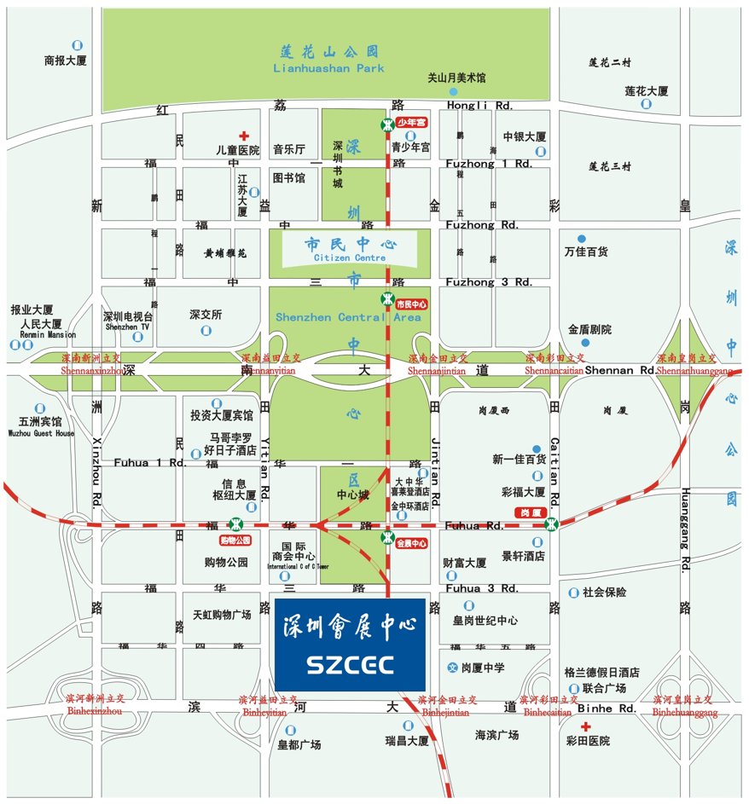

# TIME-TABLE OF ON-SITE OPERATIONS

|  |  |
| --- | --- |
| **BUILD-UP PERIOD** | **DATE/TIME** |
| Hall Opening for Raw Space Only Contractor | 29- 30 March 2025 8:30 |
| Hall Closing for Raw Space Only Contractor | 29 March 2025 17:00  30 March 2025 21:00 |
| Registration of Exhibitors / Hall Opening for Exhibitors | 29 March 2025 9:00  30 March 2025 8:30 |
| Hall Closing for Exhibitors | 29 March 2025 17:00  30 March 2025 21:00 |
| Onsite Electricity supply | 30 March 2025 (Time to be notified separately) |
| Onsite Compressed air supply | 30 March 2025 (Time to be notified separately) |
| Completion of exhibits move-in / machine positioning | 30 March 2025 16:00 |
| Final hall cleaning commences  All booths to be dressed and exhibits ready for viewing | 30 March 2025 17:00 |

|  |  |
| --- | --- |
| **MOVE-OUT PERIOD** | **DATE/TIME** |
| **The booth structures need to be cleared on 16 April.** | |
| Disconnection / Cut-off of all utilities | 2 April 2025 16:45 |
| Dismantling of booths /Collection of rental items | 2 April 2025 17:00 |
| Distribution of empty boxes / Exhibits re-packing | 2 April 2025 17:15 |
| All exhibits must be cleared from the exhibition hall  All booth structures must be cleared from the exhibition hall | 2 April 2025 21:00  2 April 2025 22:00 |

**Important**

1. The move-out time for the booth structure is from 18:00 to 22:00 on April 2th.

2. All personnel are not allowed to stay outside the opening hours of the exhibition hall. If exhibitors need supplies, please consult the sales for details.

3. All exhibitors and constructors should enter and arrange within the specified time. If exhibitors or constructors need to work overtime, please apply to the official venue constructor. The overtime application is valid only when the required overtime work fee is paid in cash on the day of overtime work.

4. The water, electricity, telephone, and compressed gas supply for all exhibitions will be cut off 15 minutes after the exhibition ends. Please prepare and reset the equipment before cutting off the power supply.

5. On the last day of the exhibition, exhibitors should take care of their belongings, especially small and lightweight items, especially during the busiest hours of the exhibition. Exhibitors should be vigilant.

6. The above construction time and procedures may be changed. Exhibitors can request the latest construction schedule from the exhibitor's service center during the exhibition setup period. Details of the opening ceremony, media introductions, VIP or exhibition group visits, conferences, and other activities will be announced later。

# 1. GENERAL INFORMATION

## THE EXHIBITION

**Sensor Shenzhen 2025**

Sensor Shenzhen is organized by the Sensors and IoT Industry Association and is a commercial exhibition focused on the sensor field. The association is guided and supported by the Ministry of Industry and Information Technology. By collaborating with member units of the alliance and industry associations, the alliance leverages the advantages of industry, academia, research and overall resources, accelerates the research and development of core technologies such as sensors, intelligent hardware, and IoT applications, and promotes the standardization of core technologies and key products in China's sensor and IoT industries.

At the moment when the sensor industry is facing historic and important opportunities, Sensor Shenzhen will rely on the huge domestic market to build application innovation development areas, electronic information industry clusters, and leading enterprise connections, improve the sensing and intelligent technology industry chain, promote the gathering of high-end innovation and entrepreneurship resources, and enhance the global competitiveness of the industry.

## 1.2 EXHIBTION HALL

Shenzhen Convention & Exhibition Center, Hall 7 & 8

Fuhua 3rd Road, Futian Central District, Shenzhen, China

Postal Code：518048

## DATES AND OPENING HOURS

|  |  |  |  |  |
| --- | --- | --- | --- | --- |
| Exhibition Opening Hours |  | Monday | 31 March 2025 | 9:00am – 5:00pm |
|  |  | Tuesday | 1 April 2025 | 9:30am – 5:00pm |
|  |  | Wednesday | 2 April 2025 | 9:30am – 4:30pm |

## ORGANIZER

(a) Sensors and IoT Industry Association

(b) Silicon Sensing Technology

## 1.5 SECURITY

We have engaged a **SECURITY** force from Shenzhen Convention & Exhibition Center who will do their best to ensure the safety of your exhibits. Nevertheless, you must arrange your own insurance to cover all stages of the event and be particularly careful to pack light, portable and attractive exhibits immediately after the close of the Exhibition. It is at this time theft rate is the highest. Please ensue that your booth is not left unattended until all portable items have been secured.

## 1.6 ACCOMMODATION

Hotels in China retain the right to cancel any bookings. We must caution our Exhibitors that the only safe bookings are those made through the Official Travel Agent, even though other methods booking may appear to be cheaper. The hotels sometimes offer cheaper rates in order to fill rooms, but these may be cancelled without notice to honor their commitment at a higher rate to the Official Travel Agent. Please see **FORM 12** for details.

## 1.7 ADMISSION

## (a) Exhibitors

Complimentary badges will be issued to all Exhibitors to enter the Exhibition Hall throughout the build-up, breakdown and show days. For security reason, Exhibitors must wear their Badges at all times whilst they are in the Exhibition Hall. Exhibitor Badges may not be used for contractors or persons not working on the Booth.

The Organizer retains the right to carry out **ALL REGISTRATION OF EXHIBITORS AND THEIR STAFF AT BOOTHS. Please provide us with a COMPLETE LIST of all those persons who will be on your booth**. It is therefore particularly important that you complete and return **FORM 11** and keep us informed by **EMAIL** of last minute changes.

Minors under 18 years old will not be admitted to the Exhibition premises at any time. This regulation is enforced for both security and safety reasons and applies to all stages of build-up, open days and breakdown.

Exhibitors can register and obtain the badges outside Hall 7 of the Convention and Exhibition Center after 9:00 am on April 13th.

## (b) Vistors

This exhibition is of an industry nature. The organizer committee will distribute invitation letters to relevant industry audiences. Exhibitors can also request tickets from the organizer to invite individual customers to visit. All visitors must fill out the spectator registration form before entering the venue.

Individuals under the age of 18 are not allowed to enter the exhibition, and visitors are not allowed to enter 30 minutes before the exhibition period closes.

## (c) Contractors

Only contractors approved by the official contractors are permitted to carry out construction in the Exhibition Hall. Contractors will be required to pay commissions or taxes, as appropriate to the Hall, Association or Government. To register your contractor, please fill in FORM 7 and submit it to us.

# 1.8 COMMUNICATION

Exhibitor may offer temporary telephone line for their booths and is on first-come-first-served basis. Please submit your requirements on **FORM 6**.

# 1.9 BUSINESS CENTRE

The Business Centre is located at Service Desk 212 on the second floor corridor, providing graphic design, business card printing, fax and photocopying services.

# 1.10 TRANSLATION OF PROMOTIONAL MATERIALS

Product catalogues and pamphlets in English are acceptable in China. To promote your products more effectively, we recommend a one-page technical summary sheet be prepared in Chinese for each product on display. If you wish, you may also translate your major product literature in Chinese. Please note that R.O.C., Hong Kong and Macau should not be listed under COUNTRY and the map of China should include Taiwan Province.。

Name card and any form of your promotional materials should not list R.O.C. This is strictly enforced and exhibitor will have to bear the liability and consequence should they refuse to adhere to.

# 1.11 EXHIBITION HALL SPECIFICATIONS

|  |  |  |
| --- | --- | --- |
| Venue | ： | Shenzhen Convention & Exhibition Center, Hall 7&8  Fuhua 3rd Road, Futian Central District, Shenzhen, China  postal code：518048 |
| Floor loading | ： | 5 Tons/square meter |
| Hall Floor | ： | reinforced concrete |
| Ceiling height | ： | 13 ~ 28m |
| Freight access | ： | 5m(W) x 4.5m(H) |
| Electrical supply | ： | 220V(±20%)1-phase, 50HZ  380V(±20%)3-phase, 50HZ |
| Water supply | ： | Please check with the official contractors |
| drainage | ： | Please check with the official contractors |
| Compressed air | ： | Please check with the official contractors |
|  |  |  |

**1.12 STANDARD BOOTH SPECIFICATIONS**

Standard booths will be built from modular extruded Aluminium System to the following specifications (please see FORM 1 for perspective):：

(a) Three sided hoarding

(b) The Fascia board can only be printed with only one Chinese or English company name, booth number, and company logo.

(c) Floor-to-floor flame retardant carpet

(d) One information desk

(e) Two folding chairs

(f) Three 28w LED long-arm spotlights

(g) One 3Amp S/P (500watts) socket

(h) One wastepaper basket

**1.13 STANDARD BOOTH FURNITURE CONFIGURATION**

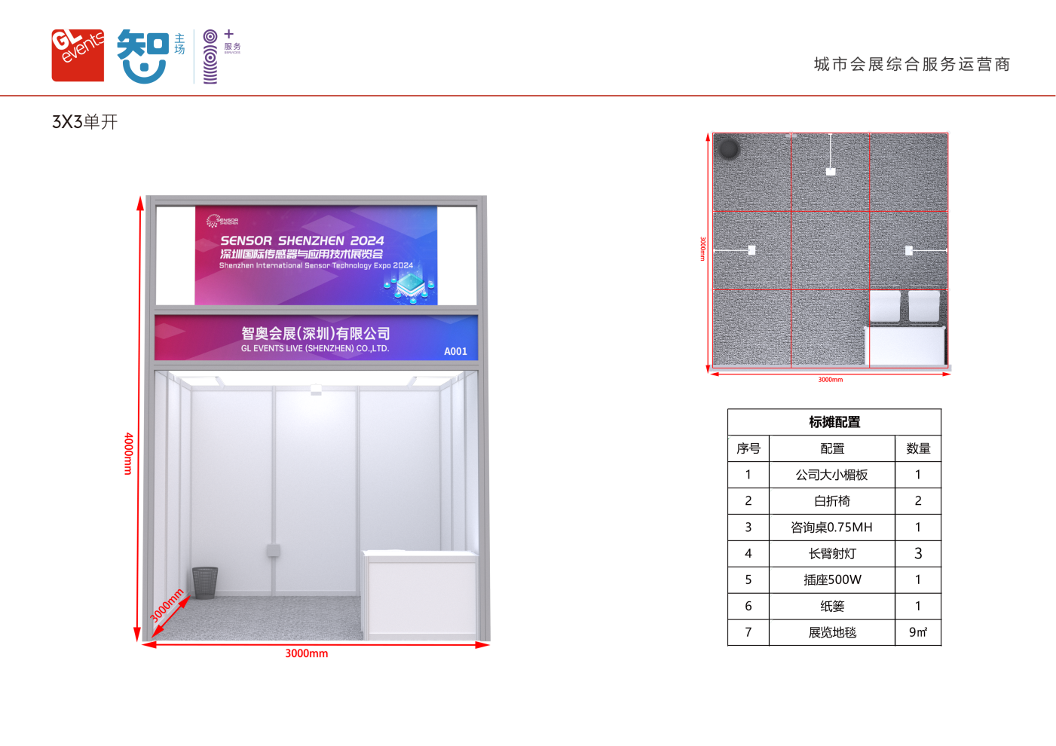

|  |  |  |  |  |  |
| --- | --- | --- | --- | --- | --- |
| **Area of Booth** | **information desk** | **folding chairs** | **wastepaper basket** | **LED spotlights** | **socket** |
| 9 sqm(1 full set) | 1 | 2 | 1 | 3 | 1 |
| 18 sqm(2 full sets) | 2 | 4 | 2 | 6 | 2 |
| 27 sqm(3 full sets) | 3 | 6 | 3 | 9 | 2 |
| 36 sqm(4 full sets) | 4 | 8 | 4 | 12 | 3 |

* Official Venue Contractor Service

1. GL event Live (Shenzhen) Co., Ltd can provide poster customize for exhibitors，detailed price demonstrating below：

Sticker post ：100 RMB / M²；

3mm thick PVC board：120 RMB / M²。

1. The price included production, installation and recycling fee, poster design is NOT included.
2. Exhibitor must prepare designed poster document.
3. If damage occurred while installing poster,official Venue Contractor Service supplier will take responsibility to reproduce it.
4. If poster falling off during exhibition opening period,official Venue Contractor Service supplier will take responsibility to repair it.
5. If the poster damaged on purpose or other reasons by man-made,official Venue Contractor Service supplier will not take responsibility.

**1.14** **CAFETERIA**

There are several fast food outlets in the Exhibition Hall.

**2.** **RULES AND REGULATIONS**

# 2.1 OBSERVATION OF RULES AND REGULATIONS

All Exhibitors and their personnel must observe the Rules and Regulations stated in this Exhibitor Manual, and those stipulated in the organizer Exhibition Participation Agreement, while working or present in the Exhibition Hall.

# 2.2 CHINESE FAIRS AUTHORITY RULING

The following are general Chinese Fairs Authority Ruling which we would like to bring to your attention. Others relating to specific topic are listed under their respective headings.

(a) The OFFICIAL BOOTH-FITTING CONTRACTOR and agents will work with their local Chinese equivalent and pay commissions or taxes as appropriate to the Hall, Association or Government

(b) Exhibitor should adhere to the following requirements when preparing promotional materials:

(i) Do not list Taiwan, Hong Kong and Macau as nations.

(ii) Do not have any contents morally unacceptable to the visitors.

1. Do not have any contents which will distort or is offensive to the host nation and other countries.
2. When drawing the map of China, please draw it in accordance with the standard one published currently.

# 2.3 MANNING AND CONDUCT OF BOOTH OPERATIONS

Your booth must be fully staffed and operational throughout the opening hours of the Exhibition, including the final day of the event. Exhibits cannot be dismantled or repacked before the show closes.

All activities of the Exhibitor and his staff must be confined to the Booth or site allocated. Exhibitors must not participate in any activity which causes, or is likely to cause, annoyance to visitors or other Exhibitors. No advertising or canvassing for business may take place elsewhere in the Exhibition Hall, nor may staff recruitment be carried out during the Exhibition, other than the search for local agents for the sale of their products.

No person participating in the Exhibition is to behave or act in a manner which may cause harm, injury or damage to other persons or exhibits, nor to Exhibition Halls property and fixtures.

# 2.4 IN-HALL FREIGHT HANDLING

For insurance reasons and to ensure proper control and co-ordination of on-site freight movement, only the Official Freight forwarder are permitted to work in the hall and operate lifting equipments unless, the consignment can be hand-carried (without mechanical equipment, such as sack-barrows, hard-wheel trollies, pallet trucks or cranes).This regulation will be strictly enforced by the venue owner and organizer.

If the exhibit is particularly sensitive, your appointed Official Freight Forwarder may request that a representative of the exhibitor to accompany and advise them on handling of their products. Details of exhibits must be submitted to your appointed Official Freight Forwarder by deadline stipulated. The exhibitor will then be informed of the date and time his exhibits are to be delivered to the Hall.

**No other lifting or handling contractor will be permitted to work in the Exhibition Hall.**

# 2.5 CUSTOMS CLEARANCE

All items and exhibits entering the Exhibition Hall must first be cleared by Customs. Only the Official Freight Forwarder can arrange for the entry and customs clearance on behalf of the Exhibitors. Exhibitors shall check with your appointed Official Freight Forwarder regarding this procedure in all - 18 - instances. Please note that any item that is not declared to the Customs office will not be allowed to leave the Exhibition Hall once brought in.

# 2.6 LOCAL DELIVERY

Exhibits should not be sent to the Exhibition Hall until the booth is sufficiently progressed to receive them. The Exhibitor and/or his representative must be present at the booth to accept delivery. The organizer will not accept responsibility for any delivery on behalf of an Exhibitor, nor will the organizer be responsible for the safe-keeping of such items after delivery.

Exhibitors may arrange delivery of their hand-carried items. However, we strongly advise you to make advance arrangements with the official freight forwarder, if you are intending to display heavier exhibits requiring lifting equipment.

# 2.7 PAYMENT FOR SPACE OR STANDARD BOOTH BOOTH

Exhibitors will not be permitted to commence booth construction or move his exhibits into the hall until full payment, including deposits, have been received by the organizer.

# 2.8 STORAGE AND WASTE MATERIALS

The organizer is unable to provide storage facilities on site for packing cases, surplus materials, and other property of the Exhibitor. Prior arrangements for the safe-keeping of such items must be made with the Official Freight forwarder. Goods must not be stored in service spaces behind or between Booths and/or walls, nor in adjacent areas.

During the move-in period, aisles in the Exhibition Areas MUST NOT be obstructed with packing materials, construction materials or debris. At the end of each day, exhibitors are responsible for ensuring that their contractors remove “off cuts” and unwanted materials from the Exhibition Hall. Painting is not permitted and sawing can only be carried out in designated areas.

Exhibitors are requested to place their waste materials in the aisle, for removal by the cleaners. The organizer reserves the right to invoice Exhibitors for the removal of EXCESSIVE packing materials, discarded crates or cartons.

# 2.9 DELIVERY AND REMOVAL OF EXHIBITS

Only personal property and hand-carried exhibits may be removed from the Exhibition Hall after the Show closes on the final day of the Exhibition.

During the opening days of Exhibition, replenishment of stock may only be delivered before the opening hours in the morning or after closing time in the evening. If you wish to remove any items of your display from the Hall during the Show days, please contact the Official Freight forwarder.

**Exhibitors are strongly advised to ensure that at least one member of their staff is on site to control the repacking of their exhibits.**

# 2.10 CENSORSHIP

All promotional materials, give-aways and audio-visual presentations (films, video-tapes and slides) must be approved by the Customs Authorities.

All Exhibitors must comply with this rule and should contact our Official Freight forwarder immediately to make all arrangements necessar

**Important: All exhibitors are advised to comply with the above-mentioned requirements. Spot checks are likely to be conducted by Government Officials during the Exhibition period**

# 2.11 PUBLIC ADDRESS SYSTEM

The Public Address System in the Exhibition Hall is for use by the organizer and the Hall Authorities for official announcements ONLY. Paging for exhibitors or visitors cannot be carried out.

# 2.12 USE OF SPREADER PLATES

Spreader plates will only be necessary if exhibits exceed the floor loading. All such requirements must be arranged in advance with the Official Freight forwarder

# 2.13 INDUSTRIAL GAS

The use of industrial gases of an inflammable or toxic nature for demonstration purposes will not be permitted within the Exhibition Hall.

# 2.14 BOOTH CLEANING

The organizer will arrange for the general cleaning of the exhibition premises and STANDARD booths (excluding exhibits and displays) prior to the opening of the Exhibition and daily thereafter. It is the responsibility of all Exhibitors to keep their own booths tidy. “Raw Space” contractors are expected to carry out daily cleaning and an initial rough clean of the booths they constructed and remove all construction debris. Exhibitors who, because of working exhibits, are likely to have substantial quantities of waste materials for removal, either during or at the end of each day, must inform the organizer in advance so that necessary arrangements may be made, for which a charge will be imposed.

# 2.15 PRESENTATION, DEMONSTRATIONS OF WORKING EXHIBITS

An exhibitor intending to demonstrate machinery or equipment on his Booth must: (a) Provide the organizer with full details in writing of any working exhibits, involving moving parts, inflammable materials, laser or other dangers and obtain approval prior to the Exhibition; (b) Give proper consideration to the conditions under which the exhibits will be demonstrated and restrict the demonstration strictly to the actual booth area; (c) No flashing lights are permitted, unless they form an integral part of an exhibit; (d) Securely install all operating machinery to prevent base slippage and position such machinery so that the operation thereof will not cause intrusion into the gangway or otherwise prove hazardous to visitors; (e) Adequately guard all moving parts of machinery to prevent injury to all persons, whether visitors, staff or contractor; (f) Isolate starting devices to prevent operation by visitors or other unauthorized persons; (g) Arrange for the exhaust to the outside of the Exhibition Hall of toxic fumes or other irritants caused by the demonstrations or exhibits; (h) Make sure that no gas or arc welding is carried out in the Exhibition Hall; (i) Remember that the use of naked flame is not permitted in the Exhibition Hall;

# 2.16 SOUND LEVEL

Ensure that sound levels caused no interference with, nor annoyance to visitors or other Exhibitors. Speakers and other sound devices should be positioned so as to direct sound into your booth and not the aisles. Where a high level of noise or other objectionable factor is involved, demonstrations may only take place at the times as stipulated by the organizer, who reserve the right to - 20 - reduce the sound level or switch off audio / visual displays causing problems if the sound level is over 75 decibel. The organizer’ decision is final in any dispute arising.

# 2.17 FURNITURE

A full range of items is available on hire from the Official Booth-fitting Contractor. Please submit your requirements on FORM 2. When the Show closes on the final day, please check that nothing is left inside drawers or cupboards when the contractor collects rental furniture.

# 2.18 BOOTH-FITTING REGULATIONS

# (a) “Raw Space Only” Sites:

1. It is possible to admit booth-fitting contracting firm other than the Official Booth-fitting Contractor. If an Exhibitor or National Group employs another such contractor they are personally responsible for negotiating the rates of commission and paying the taxes levied by the HALL MANAGEMENT. Please submit their details to the Official Booth-fitting Contractor on FORM 7 on or before 15 March 2024.
2. For exhibitors who rent raw space, please submit the perspective view and floor plan of the booth (indicating the dimensions of length, width, and height) to the official venue constructor of the conference for approval before March 15, 2024.

The designated builder of the conference has the right to refuse to approve the design sketches and plans, or request exhibitors to make modifications. If an unapproved bare space booth is required to make any changes on-site, all responsibilities and expenses shall be borne by the exhibitor. The builder is required to construct according to the approved drawings, and any changes must be approved in writing by the designated venue constructor of the conference.

1. All water, electricity, communication network and other equipment and facilities must be declared to the designated venue constructor of the conference before February 28, 2025. Late application or payment may not guarantee the supplier and will incur a 30% surcharge. (Application Platform - Zhiao Exhibition official venue constructor Platform) http://zhan.zzxes.com.cn ）
2. The construction of upgrade booth must comply with the relevant construction height restrictions of the organizing committee.

|  |  |  |
| --- | --- | --- |
| **Hall** | **Both Area** | **Height Limit** |
| 7 & 8 | ≥18 sqm | **4.5m** |

**It is strictly prohibited to build double-decker booths.。**

(v) A 0.6 meter clearance between existing hall walls and booth walls is required

1. No fitting or display may be attached, nailed, screwed or drilled onto any other part of the building. In case of damages, exhibitor / contractor concerned will be charged for the damage done
2. No Flashing / Blinking lights/floodlights or Neon-signs will be permitted.
3. No part of any structure may extend beyond the boundaries of the site allocated. This includes Exhibitor’s name, logo or light fittings,etc.
4. No suspensions are to be made from the ceiling of the Exhibition Hall. If require, please inform organizer first.
5. The name and booth number of the Exhibitor must be prominently displayed. If this rule is not observed, the organizer reserves the right to affix booth numbers as they consider fit and to charge the cost incurred to the Exhibitor.
6. A suitable floor covering, such as carpet, must be provided for booths. The use of paint or glue on the floor is strictly forbidden.

A back wall must be provided, except in the case of an island booth. The maximum height of the back wall is limited height (depending on booth location) where maximum height under 2.18 (a) (iv) allows. The organizer reserves the right to request an exhibitor to change, modify, lower or shorten any back wall, if such, in the opinion of the organizer, may obstruct the reasonable view or exposure of other exhibitors’ stands.

1. In consideration of halls and health measures, all works in the Exhibition, should be confined to installation and minor alteration works only. Fabrication works like welding, cutting, sawing, laminating, painting, spraying etc. should not be carried out inside the exhibition hall. Severe penalties will be imposed on anyone who infringes this regulation
2. Any barrier that runs from one end of the booth to the other is not allowed (Perimeter Island booths are the exception to this rule). For sides of booths that are “walls” of some kind (including ones made of solid or frosted materials), these partitions cannot extend to more than half the length of that side.
3. Each Exhibitor is responsible for providing their own walls. Where booths are adjacent, an Exhibitor may not use the reverse of the neighboring booth’s wall
4. Where a structure, such as a wall or a sign, exceeds the height of the neighboring booth’s wall, the Exhibitor with the higher wall must decorate the visible portion to a standard acceptable to the organizer.。
5. Where a “Raw Space Only” booth is located adjacent to a STANDARD BOOTH Package Booth, the walls of the STANDARD BOOTH Package may not be utilised by the “Raw Space Only” exhibitor.
6. The outer surface of “Raw Space Only” booth construction must be surfaced and decorated if visible from the aisles.
7. Exhibitors who wish to cover a portion of their booth for video presentation must submit duplicate drawings to the Official Booth-fitting Contractor for approval. Ceilings should be constructed of large mesh or egg box materials which will permit the passage of water in the event of fire.
8. Construction work must give due allowance for electrical and telephone wiring to be done. Similarly, these wires, if laid, must not be removed, cut or diverted without the permission of the organizer.
9. Exhibitors are reminded that it is the responsibility of their appointed booth-fitting contractor to carry out daily cleaning and an initial rough clean, before handing over to the exhibitor. Any leftover construction materials will be the responsibility of the exhibitor’s appointed booth-fitting contractor
10. The exhibitor cannot display his name boards or signs over the sides another adjacent exhibitor’s back wall or side wall other than on this own sides. Any structures to be used for logos and graphics like towers and signboards should be set in by least half a metre from the common walls.
11. Booths should be solidly built. All construction materials (including: display racks, boards, panels and performance stages) must be non-combustible or flame retardant. Combustible materials can only be used after going through fire prevention treatment to reach the requisite level of flame retardation. The use of flammable foam board, elastic cloth, or wood-based paneling, without pre-treatment to prevent fire, is forbidden. As is the use of petro-chemical plastic sheets for booth construction and decoration. Sprinklers should be installed in booths, suspended from the ceiling.
12. Booth-fitting contracting firm must provide insurance document adequately coverage against any and all eventuality throughout the entire exhibition for personnel, third party liability claims and movement of equipment in and out of exhibition hall. Please refer FORM 3.
13. **“STANDARD BOOTH & Upgrade STANDARD BOOTH”**
14. No additional booth-fitting or display may be attached to the STANDARD BOOTH & Upgrade STANDARD BOOTH structure. Neither nailing nor drilling will be allowed. If you require assistance in hanging or displaying your exhibits, please consult the Official Booth-fitting Contractor.
15. No painting or wall-papering on the STANDARD BOOTH booth panels will be allowed. Exhibitors who wish to have the panels painted must inform the Official Booth-fitting Contractor who will provide a quotation for the requirement.
16. No free-standing fitment may exceed a height of 2.5 metres from the floor or extend beyond the boundaries of the site allocated. This includes company names, towers, balloons and logos provided by the Exhibitor.

If exhibitors fail to use all the equipment included in the standard booth, the organizing committee will not refund the price or barter.

1. STANDARD BOOTH booth exhibitors are not allowed to change the fascia boards, which includes changing design, structure and color.
2. Exhibitors are not allowed to change the booth format by dismantling the STANDARD BOOTH structure or removing any integral part of it without prior written approval from the organizer. Such applications should be submitted to the organizer for approval at least one month before the show.

# 2.19 ELECTRICAL SERVICES

For safety reasons and for protection of the sophisticated electrical installation system of the Centre, all power main installations from source to outlet (exhibition booths) must only be carried out by the Official Electrical Contractor. Connection of exhibits in booths may be carried out either by the Official Electrical Contractor or by the Exhibitor’s technician, but, connections must be inspected by the Official Contractor before circuits will be made live.

Electrical arrangements for booths have been divided into three sections; please see FORM 4 for clarity.

**STANDARD BOOTH Electrical installations**

1. The STANDARD BOOTH already contains electric lighting
2. The socket is only for general electrical appliances, such as laptops.
3. Each socket is only used for one type of instrument, and cable trays are not suitable. If exhibitors require additional power supply services, please fill out Form 4 (Power Application).

**Raw Space Electrical installations**

The raw space booth does not include electrical devices and requires additional rental of lighting and power supply.

Exhibitors must lease independent power sources for all exhibits that require power supply for demonstration purposes. Each type of power supply service is only used for one type of instrument or machine, and cable trays are not applicable. If exhibitors require additional power supply services, please fill out Form 4 (Power Application) and submit it along with the location map. If there are any changes, please notify the contractor immediately, otherwise all on-site changes will be considered as new applications. If exhibitors need to apply for power supply services that are not listed in the table, the contractor can provide a separate quotation for reference. Please ensure that the exhibits comply with the power supply standards listed in 1.11. Exhibitors can provide their own transformers, adapters, or regulators. If the domestic voltage may be unstable, please bring your own current stabilizer. All applications for power supply leasing are approved by the official contractors of the conference.

The official contractors should try to avoid installing the distribution box on the booth (bare ground and standard booth), but there is still an inevitable possibility. All electrical devices (including wires, boxes, etc.) must be fixed and must not exceed the range of the booth.

Lighting fixtures should be kept 0.5m or more away from flammable objects. Ballasts for fluorescent lamps, high-pressure mercury lamps and other lighting fixtures must not be installed on in the 1m range of flammable or combustible objects.

You may bring with you any transformer, adaptor or regulator. Orders will also be accepted by the Official Electrical Contractor. A fluctuation of approximately ± 20% is possible. EXHIBITORS WHOSE EQUIPMENT IS PARTICULARLY SENSITIVE SHOULD ARRANGE STABILISERS.

No electrical installation and fitting may be suspended from the ceiling of the Exhibition Hall or fixed to any part of the building structure

Supplies to booths will be switched off at source 15 minutes after the Exhibition closes each evening. On the final day of the Exhibition, electricity will be cut off 15 minutes after the Exhibition closes.

Exhibitors requiring electrical supply at times other than those stated should make prior application to the organizer in writing 2 weeks before the Exhibition Opening date. Any cost involved must be borne by the Exhibitor. It is essential that you submit this information in good time as it may not be possible to meet late orders. The organizer reserve the right to disconnect the electrical supply to any installation, which in the opinion of the Electrical Engineers, is dangerous or likely to cause annoyance to visitors or other Exhibitors. **Note: Please place orders early as electrical plans have to be submitted to the Centre Facility Section for approval.**

# 2.20 COMPRESSED AIR

Rental of compressor must be ordered from the official booth fitting contractor. Compressors powered by internal combustion engines will not be permitted in the Exhibition Hall. Please indicate your requirements on FORM 5. Supply is not totally “clean” and “dry”, Exhibitor must arrange their own filters if necessary.

# 2.21 AIR-CONDITIONING

If necessary, the organizing committee will uniformly arrange air conditioning services for the exhibition hall during the exhibition period. Exhibitors are strictly prohibited from installing air conditioning equipment inside the booth without permission. Once discovered, the organizing committee has the right to take power outage measures.

# 2.22 PHOTOGRAPHY

Commercial photographers representing the appropriate Media or individual visitors to the Exhibition may wish to photograph your booth or an individual exhibit which you are showing. Please note that you have the right to request any such person not to carry out photography without your specific permission. A general photograph taken along the length of the aisle would not require specific permission, whilst “head on” photograph or a “close up” of any of your exhibits lies within your jurisdiction. Exhibitors wishing to restrict photography for any reason should place a notice to that effect adjacent to the exhibit and are advised to hire a security guard at their expense to enforce it.

**2.23 FIRE PRECAUTION**

Exhibitors, who, because of the nature of their exhibits, require a special type of fire extinguisher, must make arrangements, at their own cost, for the provision of such equipment. The organizer will assist and advise if required. Any person seeing an outbreak of fire, however slight, must make immediate use of the fire alarm system and make every endeavor to extinguish the outbreak or to confine it by the use of extinguishers and / or removal of goods in the vicinity. **NO SMOKING IS PERMITTED IN THE EXHIBITION HALL.**

# 2.24 FORCE MAJEURE

The Exhibition may be postponed, shortened or extended, due to any cause whatsoever beyond the control of the organizer. The organizer shall not be responsible for any loss sustained by Exhibitors, directly or indirectly, attributable to the elements of nature, force majeure or orders and directives - 26 - imposed by any Governmental Authority. In the event of such circumstances, the money paid by the Exhibitors, the organizer has the right to decide refund or not, and will not pay to related staff.

# 2.25 DILAPIDATION

The organizer in conjunction with the Landlord will inspect the halls before build up and after breakdown of the Exhibition. Exhibitors are responsible for the cost of making good or replacing any damages or dilapidation to the Exhibition premises, whether caused by them, their agents, contractors or any person or persons employed or engaged on their behalf by such agents or contractors. Exhibitors occupying STANDARD BOOTH Booths are also responsible for the cost of making good, restoring or renewing any damage or dilapidation to their STANDARD BOOTH structure, floor covering, light fittings, or any part thereof, whether caused by themselves, their agents, contractors or by any person or persons employed or engaged on their behalf by such agents or contractors. The cost of making good any damage will be assessed by the official booth-fitting contractor and charged to the Exhibitor concerned.

# 2.26 AUTHORITY ON THE PREMISES

The organizer shall be responsible for and be entitled to act as the Owners of the premises throughout the whole period of the event. Nevertheless, the organizer is subject to the Rules and Regulations imposed by the Hall Management, MII, Safety & Security Authorities and the respective Government Authorities.

# 2.27 HAND-OVER OF HALL

The exhibition will close at 16:30 on 2 April, 2025. The hall will remain open until 21:00 on 2 April, 2024 to allow for the removal of hand-carried goods. Please ensure at least one staff stays on the booth to protect exhibits safely. All exhibits must be cleared and booth fitting materials must be moved away before 21:00 on 2 April. Any items remaining will be disposed of by fastest means possible. The organizer cannot accept responsibility for any loss or damage and any costs involved must be borne by the Exhibitor

# 2.28 Apply for the 'Temporary Truck Pass' in Shenzhen urban area

(1) Due to the implementation of urban traffic control in Shenzhen, all transportation vehicles (1.5 tons and above) entering the urban area of Shenzhen must apply for a truck pass in advance, and enter the exhibition site according to the specified route within the specified time. The only route of approved trucks with yellow number plate is through the Huanggang toll station of G4 Guangzhou Shenzhen Expressway to enter and exit Shenzhen city. Therefore, the following special requirements are made for trucks that are arranged or withdrawn. If the early procedures are not completed as required, or if the specified time is not met Driving on the route will be recorded and fined by the "electronic eye", and the consequences will be borne by oneself. The schematic diagram for entering and exiting the museum is as follows:

(2) Trucks are prohibited from passing between 7:30 to 9:30 and 17:00 to 20:00 every day. Please avoid entering the urban area of Shenzhen during this time period.

(3) Special requirements for trucks with blue number plate: No truck pass is required, but they must be driven according to the prescribed route, and are prohibited from passing from 7:00 to 9:30 and from 17:00 to 20:00 every day.

(4) If there is a demand for a truck with yellow number plate, please apply before March 21, 2025. The license will be sent to the application email one after another, please check and receive it (the specific application process will be notified later).

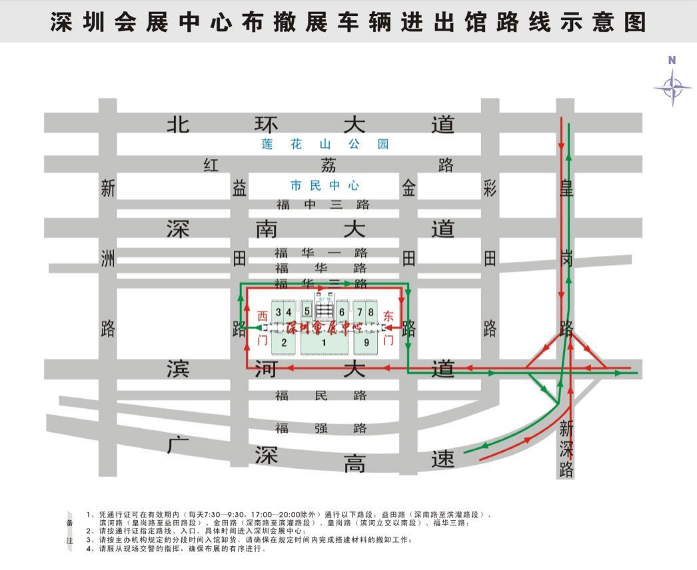

**Form-1** Standard Booth Fascia Board

**Deadline： 2025/2/28**

All standard booth exhibitors are required to send the fascia information file as required to the official construction service by email before February, 28, 2025.

If you do not complete the submission before the deadline, the company information and conference design on the exhibition application form will be adopted..If you need to modify the Fascia information on site, you will need to pay corresponding additional fees.

1. Please fill out company name correctly（18 letters maximum in Chinese /25 letters maximum in English），including space and symbol，and fill it in Block form.
2. If you need to modify the Fascia information on site, you will need to pay corresponding additional fees.
3. All letters are unified.

Company Name（Chinese）

|  |  |  |  |  |  |  |  |  |  |  |  |  |  |  |  |  |  |
| --- | --- | --- | --- | --- | --- | --- | --- | --- | --- | --- | --- | --- | --- | --- | --- | --- | --- |
|  |  |  |  |  |  |  |  |  |  |  |  |  |  |  |  |  |  |

1 2 3 4 5 6 7 8 9 10 11 12 13 14 15 16 17 18

Company Name（English）

|  |  |  |  |  |  |  |  |  |  |  |  |  |  |  |  |  |  |  |  |  |  |  |  |  |
| --- | --- | --- | --- | --- | --- | --- | --- | --- | --- | --- | --- | --- | --- | --- | --- | --- | --- | --- | --- | --- | --- | --- | --- | --- |
|  |  |  |  |  |  |  |  |  |  |  |  |  |  |  |  |  |  |  |  |  |  |  |  |  |

1 2 3 4 5 6 7 8 9 10 11 12 13 14 15 16 17 18 19 20 21 22 23 24 25

|  |  |
| --- | --- |
| **Exhibitor Information：**  Company Name:  Booth Number: Contact:  Phone: Mobile:  Email address: Date: | Please submit the content and email to**：** |
| **Silicon Sensing Technology, Co.Ltd**  Contact：Mingfei Wan  Email Address：[wanmingfei@sistiot.com](mailto:wanmingfei@sistiot.com) |

**Form-2** Furniture Rental Form for Standard Booth

**Deadline： 2025/2/28**

|  |  |  |  |  |  |  |  |  |  |  |
| --- | --- | --- | --- | --- | --- | --- | --- | --- | --- | --- |
| **No.** | **Item** | **Dimension (L×W×H) mm** | **Unit** | **Price（RMB）** |  | **No.** | **Item** | **Dimension (L×W×H) mm** | **Unit** | **Price（RMB）** |
| 1 | Folding chair | White | Pcs | 25 | 17 | Ladder Counter | 750/1000×500×1000mmH | Pcs | 250 |
| 2 | Gourd chair | White | Pcs | 50 | 18 | Single arc-shaped Cabinet | 750mmH | Pcs | 250 |
| 3 | Leather chair | Black | Pcs | 80 | 19 | Single sofa | 780×780×800mmH | Pcs | 250 |
| 4 | Lift bar chair | White | Pcs | 90 | 20 | Two-seats sofa | 1350×800×800mmH | Pcs | 350 |
| 5 | Makeshift Table | 750×500×1000mmH | Pcs | 70 | 21 | One meter chain post(2 minimum rental) | 1m | m | 50 |
| 6 | Information Counter A | 750×500×1000mmH | Pcs | 90 | 22 | Collapsable Table | 500×1200×750mmH | Pcs | 120 |
| 7 | Information Counter B | 1000×500×1000mmH | Pcs | 100 | 23 | Long Arm Spotlight | 28W | Pcs | 80 |
| 8 | Glass Round Table | R800mm | Pcs | 120 | 24 | Metal Halide Lamp | 100W | Pcs | 200 |
| 9 | Wooden Round Table | DM600x740mmH | Pcs | 180 | 25 | Tablecloth | 1500×1500mm | Pcs | 50 |
| 10-1 | Flat Shelf | 950×300mm | Pcs | 40 | 26 | Planet（*Dracaena arborea*） |  | Pot | 50 |
| 10-2 | Sloped Shelf | 950×300mm | Pcs | 40 | 27 | Planet  （*Dypsis lutescens*） |  | Pot | 80 |
| 11 | Low cabinet(Locker) | 750×500×1000mmH | Pcs | 150 | 28 | Water dispenser | Including 2 barrels of drinking water | Unit | 120 |
| 12 | Low display cabinet | 1000×500×1000mmH | Pcs | 280 | 29 | Water dispenser |  | Barrel | 30 |
| 13 | High display cabinet | 2000×500×1000mmH | Pcs | 450 | 30 | Refrigerator | 93Litre | Unit | 800 |
| 14 | Carpet | Any Color | ㎡ | 25 | 31 | Socket |  | Pcs | 50 |
| 15 | Folding door | 950×2000mmH | Pcs | 160 | 32 | Remove Board | 1000×2500mmH | Pcs | 50 |
| 16 | Plasma TV | 42inch | Unit | 1100 | 33 | Adding Board | 1000×2500mmH | Pcs | 100 |

Note:

1. The prices quoted for the above items are rental prices, unless otherwise specified, the rental period is one exhibition period; This service only provides for standard booth exhibitors;

2. If the booking fee is not paid or the exhibition equipment is rented on-site (during the exhibition setup period), the supply may not be guaranteed; Please book and pay in advance;

3. Exhibition equipment that is standard, reserved, or has been delivered to the booth cannot be returned or exchanged; If the pre lease time is exceeded and the above projects are applied for on-site, a 30% surcharge must be paid;

4. Pre lease application: http://zhan.zzxes.com.cn (Pre lease deadline: March 28, 2024)

5. Pre lease consultation: Mr. He 0755-81488483-650/18128860258

**（以下图片仅供参考）**

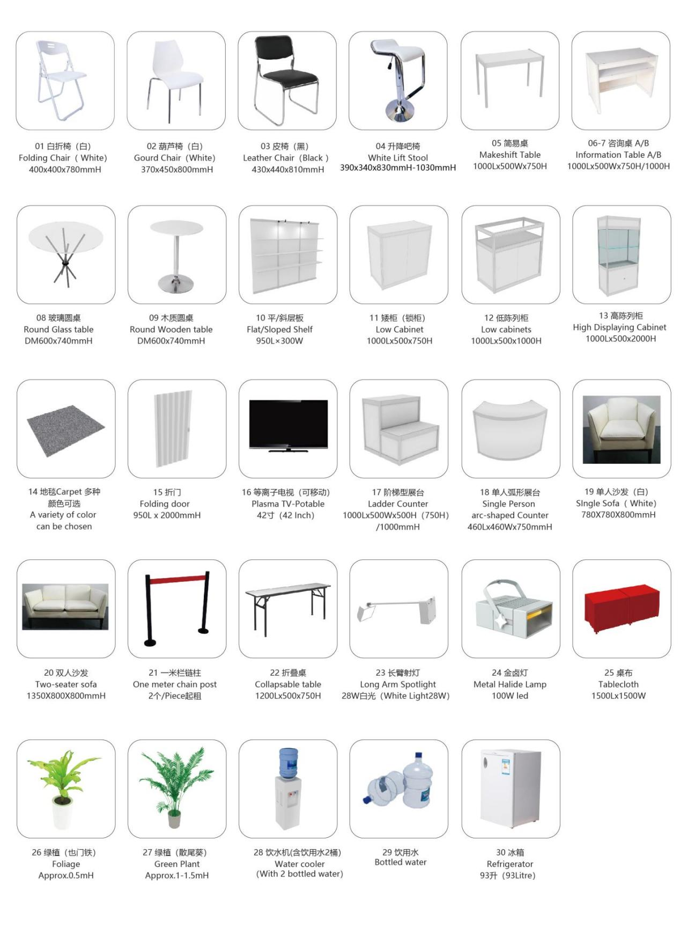

**Form-3 Special Booth Fee and other Service Application**

**Deadline： 2025/2/28**

***Please log into Official Venue Constructor Website to submit（<http://zhan.zzxes.com.cn> ）before deadline（New user need to sign on first）***

**Worker Pass Fee, License Fee, Management Fee and Booth Deposit**

|  |  |  |
| --- | --- | --- |
| **Specification** | **Price (RMB)** | **Reference** |
| Management Fee | 35RMB/㎡ | Necessary for Raw Space |
| Drawings Reviewing Fee | 10RMB/㎡ |  |
| Worker Pass Fee(Updated) | 20RMB/Unit | Necessary for entering in hall for raw space construction. One pass for one person. Please contact official contractor for details. |
| License Fee | 50RMB/Unit | Necessary for entering in hall for  raw space construction. One license for one booth. |

Construction Deposit

|  |  |  |
| --- | --- | --- |
| **Size** | **Cleaning/Construction Deposit** | The cleaning deposit and construction safety deposit shall be paid based on the area of the special booth.  It is recommended to pay at the on-site service desk through credit card pre authorization and the refund to account should be completed within 60 days after the end of the exhibition. |
| Below 100M2 | 15000RMB |
| 101M2-300M2 | 20000RMB |
| Above 300M2 | 30000RMB |
| Remarks:  1. Deposit refund voucher: Clean up the exhibition and contact the venue staff for cleaning confirmation, and obtain a cleaning confirmation form as a voucher.  2. Deposit deduction and punishment: During the construction period (including the preparation and removal period) and exhibition period, if there are violations of the relevant regulations of the exhibition and fire safety regulations, major or minor accidents, or booth cleaning is not clean, The exhibition manager will deduct the deposit from the construction company according to regulations (see the relevant management regulations of the official service manual for details) and provide a deduction explanation.  3. Deposit refund instructions (note: Please choose the payment method that meets your company's payment and refund requirements according to the requirements of the official Venues constructor instructions):  1) Online payment method:  ① Pay through WeChat and Alipay: After the exhibition, you can log in the "Application for Deposit Return" module of the official service platform, and select WeChat and Alipay return to apply for deposit return. (Within three months from the payment date, returns can be made through this operation. Only company accounts can be returned after three months, and private accounts cannot be returned.)  ② Payment through banking wire: You can log in to the official service platform "Apply for Deposit Refund" after the exhibition ends, and choose to apply for deposit refund through bank account refund. Our company will refund your company's bank account through online banking based on the provided bank account information (banking wire does not support private account refunds).  2) On site card swiping format:  ① Pre authorization form: Using a credit card, freeze the current swiping amount in the bank card in the form of pre authorization. The frozen amount will be automatically unfrozen within 30 days from the end of the exhibition, and there is no need to log in to the official service platform to apply. If the expiration date has not been unfrozen, please call the issuing bank.  ② Payment by swiping a savings card: You can log in to the "Application for Deposit Refund" module on the official service platform after the exhibition and choose to apply for deposit refund through bank account refund. Our company will refund your company's bank account through online banking based on the provided bank account information. Please complete the deposit refund application as soon as possible after the withdrawal. (Swiping savings cards does not support private account refunds) | | |

**Overtime**

|  |  |  |  |
| --- | --- | --- | --- |
| **Specification** | **Time period** | **Unit** | **Price/Unit** |
| The area of overtime fee shall be calculated starting from 36 m2, and the area not exceeding 36 m2 shall be calculated as 36 m2 | 17:30~22:00 | m2/Period | 25RMB |
| 22:00~24:00 | m2/2 hours | 30RMB |
| Remarks:  1. Working hours during the exhibition setup period: On the evening of March 29, 2025, the working hours will end at 17:30; On the evening of March 30, 2025, the working hours will expire at 22:00  2. If the above working hours are exceeded, exhibitors should apply to the designated official venue constructor GL live (Shenzhen) Co., Ltd. (on-site service desk) designated by the organizer before 15:00 on the same day and complete relevant procedures. If the application is delayed, a 10% additional fee will be charged.  3. Payment method: Alipay/WeChat/credit card.  4. In principle, it is not allowed for builders to work overtime after 24:00. In special circumstances, if overtime is required after 24:00, the official venue contractor shall apply to the venue and obtain approval before implementation. After 24:00, the charging standard is 35 yuan/square meter/2 hours. | | | |

**Form-4 Power Rental Service**

#### 所有光地展位必须回传！

**Deadline： 2025/2/28**

***Please log into Official Venue Constructor Website to submit（<http://zhan.zzxes.com.cn> ）before deadline（New user need to sign on first）***

|  |  |  |  |  |
| --- | --- | --- | --- | --- |
| **NO.** | **Specifications** | **Apply before pre-lease on February 28, 2025 and enjoy discounted prices** | **Apply after the deadline of February 28, 2025 and charge the original price** | **Remarks** |
| **Price** | **Price** |
| **Single-phase electricity (lighting electricity is used separately from mechanical electricity)** | | |  | 1. Refer to and implement the relevant management regulations for power connection in the exhibition hall;  2. The price includes material fees, construction fees, management fees, and electricity fees;  3. Outdoor electricity will be charged 100 RMB per m² for management and installation fees;  4. This is the price for the exhibition period, which will be charged at 20% of the rental price for every day exceeding (including electricity and manual duty);  5.The electricity for booth lighting and machinery should be used separately, and LED electricity needs to be independent of the electrical box |
| 1 | 220V/10A(<2KW) | 750RMB/exhibition period | 975RMB/exhibition period |
| 2 | 220V/16A(<3KW) | 1100RMB/exhibition period | 1430RMB/exhibition period |
| 3 | 220V/32A(<6KW) | 2250RMB/exhibition period | 2925RMB/exhibition period |
| **Three-phase electricity (lighting electricity is used separately from mechanical electricity)** | | |  |
| 1 | 380V/16A(<8W) | 1800RMB/exhibition period | 2340RMB/exhibition period |
| 2 | 380V/32A(<16KW) | 3120RMB/exhibition period | 4050RMB/exhibition period |
| 3 | 380V/63A(<32KW) | 5150RMB/exhibition period | 6695RMB/exhibition period |
| 4 | 380V/100A(<50KW) | 9650RMB/exhibition period | 12545RMB/exhibition period |
| **Temporary electricity for construction during the exhibition period** | | | | |
| 1 | 220V/15A | 500RMB/Preparation period | 650RMB/Preparation period |  |
| 2 | 380V/15A | 650RMB/Preparation period | 845RMB/Preparation period |  |
| Note：   1. If the electricity consumption of the standard booth exceeds 500W, please apply for separate electricity usage. This project does not provide leasing on site, please apply for pre leasing in advance. 2. The power connection service must **submit an application and make payment before February 28, 2025 during the pre lease period. Late applications will incur a 30% order delay fee, and on-site supply is not guaranteed;** **(Based on the time of payment receipt)** 3. **If a reserved or installed power connection needs to be returned or replaced, a 30% handling fee of the original price must be charged; If the location needs to be moved, it is only allowed to move within the original booth, and a transfer fee must be charged (50% of the on-site price of the transfer facility);** 4. Booths that require early opening of electricity during the exhibition period during the move-in/move-out period must apply for and complete the procedures for early/delayed electricity use at the service counter (second floor service counter of Shenzhen Convention and Exhibition Center). The application cycle is 4 hours, and those less than 4 hours are calculated as one cycle. 5. Please apply for 380V/100A and 380V/150A power supplies to the venues contractor before March 18st. Applications will not be accepted after the deadline. 6. Please refer to the "Management Regulations" for the relevant regulations on power connection; The main switch protection setting value of the main control box for booth electricity should be less than or equal to 80% of the fixed power box switch protection setting value connected to the exhibition hall, to ensure the safe operation of the exhibition hall power supply system. 7. During the exhibition set-up and opening, as well as during the closing and withdrawal periods, the exhibition hall will strictly follow the prescribed time for unified power transmission and power outage. Exhibitors must ensure that all electrical equipment and   The facility will automatically power off in advance. If the exhibition equipment fails to power off in advance and causes damage to the electrical equipment and facilities, all losses and consequences shall be borne by the equipment owner or user themselves. If any damage or accidents to the exhibition hall's electrical facilities are caused as a result, the equipment owner or user shall also bear the responsibility;   1. **Special reminder:** For intentional concealment, underreporting, or underreporting of electricity consumption, a penalty of 2-5 times the severity of the situation will be imposed. If personal injury or property loss accidents occur as a result, the parties involved will also be held legally responsible. 2. Consultation ：Mr. He 0755-81488483-650 /18128860258 | | | | |

**Form-5 Water & Compressed Air** **Application**

**Deadline： 2025/2/28**

***Please log into Official Venue Constructor Website to submit（<http://zhan.zzxes.com.cn> ）before deadline（New user need to sign on first）***

|  |  |  |  |  |  |
| --- | --- | --- | --- | --- | --- |
| **No** | **Power KW/HP** | **Pressure**  **(kg)** | **Air volume (liters/min)** | **Apply before pre-lease on February 28, 2025 and enjoy discounted prices** | **Apply after the deadline of February 28, 2025 and charge the original price** |
| **（Power and Machine included）** | |
| 1 | 2HP | 8kg | ≤0.16cubic meters per minute | 1820RMB | 2350RMB |
| 2 | 3HP | 8kg | ≤0.25cubic meters per minute | 2340RMB | 3050RMB |
| 3 | 5HP | 12kg | ≤0.40cubic meters per minute | 3250RMB | 4200RMB |
| 4 | 7HP | 12kg | ≤0.60cubic meters per minute | 3900RMB | 5050RMB |
| 5 | 10HP | 12kg | ≤0.80cubic meters per minute | 4300RMB | 5550RMB |
| 6 | 15HP | 12kg | ≤1.00cubic meters per minute | 4900RMB | 6400RMB |
| 7 | 20HP | 12kg | ≤1.50cubic meters per minute | 5600RMB | 7250RMB |
| **Dryer model** | | **Price of dryer**  **(RMB)** | **Filter flow rate**  **(liters/min)** | | **Filter price**  **(RMB)** |
| 1 | HDR-10A、15A、20A | 1050RMB | 3500、6000、2400 | | 520RMB |
| 2 | HDR-7.5A | 800RMB | 1500 | | 400RMB |
| Note：   1. The above rental price is the rental fee for an air compressor during one exhibition period, including the cost of compressor power supply; 2. The dryer and filter can be rented separately according to needs, and the cost will be calculated separately; 3. The rental project in this form must submit an application and make payment before February 28, 2025 during the pre lease period. Late application or payment may not guarantee supply and will incur a 30% surcharge. (Based on the time of payment receipt) 4. 1 kg pressure=0.98 bar ≈ 1 bar . 5. If the booth has rented an air compressor, it is recommended to also rent a dryer for use. | | | | | |

Water Rental Service**：**

|  |  |  |  |  |  |
| --- | --- | --- | --- | --- | --- |
| **No** | **Item** | **Specifications** | **Apply before pre-lease on February 28, 2025 and enjoy discounted prices** | **Apply after the deadline of February 28, 2025 and charge the original price** | **Remarks** |
| 1 | Fixed  Water supply and drainage | DN15mm(4分) | 2080RMB/exhibition period | 2700RMB/exhibition period | Outdoor water consumption: Each contact point will be charged 100 RMB for material and installation fees |
| DN20mm（6分） | 3350RMB/exhibition period | 4400RMB/exhibition period |
| DN25mm（1INCH） | 3900RMB/exhibition period | 5050RMB/exhibition period |

**Form-6 Phone and Internet Application**

**Deadline： 2025/2/28**

***Please log into Official Venue Constructor Website to submit（<http://zhan.zzxes.com.cn> ）before deadline（New user need to sign on first）***

|  |  |  |  |  |  |  |
| --- | --- | --- | --- | --- | --- | --- |
| **No** | **Item** | | **Deposit(RMB)** | **Apply before pre-lease on February 28, 2025 and enjoy discounted prices** | **Apply after the deadline of February 28, 2025 and charge the original price** | **Remarks** |
| **Price** | **Price** |
| 1 | Phone | Local Call（LDD） | Telephone:200RMB/Unit | 650RMB/Unit•exhibition period | 845RMB/Unit•exhibition period | Including city call fees (limited to calling voice service) |
| 2 | DDD | Telephone:200RMB/Unit | 780RMB/Unit•exhibition period | 1015RMB/Unit•exhibition period | Including city/domestic long-distance call fees. (Restrict calls to voice service) |
| 3 | IDD | Telephone:200RMB/Unit  Pre-payment: 2000RMB/Unit | 780RMB/Unit•exhibition period | 1015RMB/Unit•exhibition period | Including city/domestic long-distance call fees. International call fees are calculated based on actual circumstances (limited to calling voice service stations) |
| 4 | Wire Changing | - | 200RMB/Wire/Time | | Material and labor costs |
| 5 | Internet | LAN connection | - | 780元/IP•exhibition period | 1015RMB/IP•exhibition period | The hall shares a bandwidth of 300M, and only one computer is connected to the internet. The use of routers is prohibited. |
| 6 | ADSL 100M | | Download 100M,Upload 10M | 2575RMB/exhibition period | 3345RMB/exhibition period | This line is provided by China Telecom and does not provide a router. |
| 7 | ADSL 200M | | Download 200M，Upload20M | 3485RMB/exhibition period | 4530RMB/exhibition period |
| 8 | IP LAN 10M | | Download 10M，Upload10M | 21060RMB/exhibition period | 27378RMB/exhibition period | This line is a fiber optic line provided by China Telecom, and applications will be received after March 18, 2025. |
| 9 | IP LAN 20M | | Download 20M，Upload20M | 28600RMB/exhibition period | 37180RMB/exhibition period |
| 10 | IP LAN 50M | | Download50M，Upload50M | 40300RMB/exhibition period | 52390RMB/exhibition period |
| 11 | Remarks | 1. Network rental services will no longer be provided after 18:00 on the last day of the exhibition building period, as it is difficult to accurately locate the information points after the carpet is laid. Additionally, connecting cables may damage the carpet and decorative surface. Therefore, customers with network needs should apply in advance as much as possible.  2. The phone line in the conference room needs to be applied for 3 hours in advance (during working hours) to avoid staff being unable to connect and debug the phone line in a timely manner, which may affect the meeting time and service quality.  3. To ensure the normal operation of the exhibition hall's computer network and provide stable network services for exhibitors, it is strictly prohibited to use wired and wireless routers in the exhibition hall. If wired or wireless router devices are found to be used, the exhibition center will close their computer network ports. | | | | |

**Form-7 Special Booth Construction Application Form**

#### 所有光地展位必须回传！

**Deadline： 2025/2/28**

**Booth Number：** Exhibitor Name**：**

**Booth Data：**total area [ ]m²、Length[ ]m、Width[ ]m、High[ ]m

Builder Name **：**

|  |  |
| --- | --- |
| 1. **In order to build a special booth and ensure safe and smooth construction, our company promises to the organizer, exhibition hall, and official venue constructor as follows:** 2. Both parties have signed a construction contract, and the construction unit has legal construction qualifications and is the only designated builder for this booth. 3. Comply with the construction operation management regulations, fire management regulations, safety management measures, and other safety regulations of this exhibition. 4. The booth construction shall strictly follow the area determined by the organizer, that is, the vertical projection of the booth construction (including door heads, bay windows, decorations, etc.) shall not exceed the marked position, and shall not obstruct the fire exits (doors) of the exhibition hall in any form, and shall not be built under the yellow line of the exhibition hall. 5. The ceiling design of all booths shall not exceed 30% of the booth area. Wireless smoke sensing and spraying equipment must be installed for enclosed ceiling sealing. Open top sealing requires the installation of wireless smoke detectors and other devices when the local area is large. The ceiling area of the booth is equipped and installed according to the standard of 36 square meters per set (less than 36 square meters, calculated as 36 square meters) or by the exhibition center. The installation unit of wireless smoke sensing and sprinkler equipment must have corresponding qualifications 6. In strict accordance with the fire protection requirements, it is prohibited to use polyurethane materials such as foam words and KT plates, and it is prohibited to use decorative materials such as elastic cloth, flannelette, gauze, etc., which meet the requirements of fire B1 fire retardant materials. (On site open flame inspection) 7. All construction personnel must wear safety helmets correctly, professional tools must be equipped for climbing operations, and scaffolding must be equipped with guardrails and protected by personnel below. (The use of wooden ladders is prohibited) 8. There should be no less than 2 evacuation exits for booths or exhibition areas with a circumference greater than 75% on all four sides in the exhibition hall, and the horizontal distance between the nearest edges of adjacent evacuation exits should not be less than 5 meters. When the area of the booth or exhibition area is not more than 120 square meters, the evacuation exit adopts an open type with a net width of more than 5 meters, and the straight-line distance from the farthest point of the area to the evacuation exit does not exceed 15 meters, one evacuation exit can be set up. 9. After the booth is closed every day, all electrical equipment is turned off. Once an unclosed booth is found, the booth will cut off its normal power supply. 10. After the construction (arrangement) of the booth is completed, all remaining construction materials and waste items must be removed from the exhibition hall and properly disposed of. (Do not pile up on fire evacuation routes/safety exits or passages between booths and exhibition hall walls) 11. The exposed areas of the booth must be beautified and decorated to maintain the overall appearance of the exhibition hall and not affect the effectiveness of other booths. 12. All design drawings and other construction application materials submitted are true and will be presented consistently with the exhibition period. (Please submit according to the requirements of the submitted data items. If the design drawings do not meet the requirements of the submitted data items, no review response will be given. The review results will be based on a single submitted data item. If other submitted data items have data content that does not meet the requirements of the submitted data items, they will be treated as invalid.) 13. If there are any materials that do not comply with the drawings or complaints during the construction, installation, or dismantling of the exhibition, once verified, our company is willing to comply with the rules and regulations of the exhibition and accept the relevant penalties, and bear all adverse consequences arising from this.   The above content has been carefully read, fully understood, and will be strictly executed according to the requirements. Promise to voluntarily accept all penalties imposed by the organizer, exhibition hall, and home service provider in accordance with relevant management regulations in case of violation. Hereby promise! | |
| Exhibitor:  (Official seal)  Legal representative or safety responsible person (signature)  Person in charge of on-site safety:  contact number:  Date: | Booth contractor:  (Official seal)  Legal representative or safety responsible person (signature)  Person in charge of on-site safety:  contact number:  Date: |

**Form-8-1 Shenzhen Convention and Exhibition Center Entry Work Safety Commitment Letter**

#### 所有光地展位必须回传！

**Deadline： 2025/2/28**

In order to conscientiously implement laws and regulations such as the Safety Production Law of the People's Republic of China, the Fire Protection Law of the People's Republic of China, and the Safety Management Regulations for Large Mass Activities, further implement production safety responsibilities, strengthen on-site operation safety management in the exhibition hall, improve the safety awareness and protection responsibility of the operating units entering the exhibition hall, and maintain the safety of the exhibition hall and the public, our unit enters the exhibition hall of the exhibition center for operations, As a responsible unit for the safety of the operation area, we are willing to bear full responsibility for the consequences caused by our unit's violation of regulations during the move-in operation, and make the following solemn commitment:

**Our designated** , work phone number (mobile phone) is from (date) to (date) at the Shenzhen Convention and Exhibition Center

Booth location: Hall, booth number: , exhibitor: ;

Booth location: Hall, booth number: , exhibitor: ;

**1.** Theperson in charge of safety management in the booth operation site area is responsible for the safety implementation and rectification work of our unit at your exhibition hall operation site.

**2.** During theoperation process, strictly abide by various laws and regulations of the country and Shenzhen city regarding fire safety and construction safety management, strictly abide by the regulations of the exhibition center on construction fire safety and booth construction safety, consciously accept and obey the safety inspection and supervision of the public security organs, fire departments, and exhibition center, and promptly implement the rectification requirements proposed by the public security organs, fire departments, and exhibition center.

**3.** Theequipment and tools used for on-site operations meet safety requirements, and all special operation personnel hold certificates to work; According to the situation at the job site, equip sufficient quantities of fire equipment at the job site.

**4.** During the operation process, the construction materials used meet the fire and structural safety requirements of the exhibition hall, correctly evaluate the electrical load of the operation project, and adopt matching electrical switches and cable capacities to ensure the electrical safety of the operation project.

**5.** Strictly follow the requirements of the operation design and construction drawings, standardize the construction, and take corresponding safety protection measures in dangerous operations such as climbing and lifting to ensure the personal safety of construction personnel.

**6.** If various fire, publicsecurity, and other unexpected accidents occur during the construction operation, the on-site management personnel of the exhibition center should be notified as soon as possible, and it is obligated to take necessary protective measures in advance to prevent the accident from further expanding.

**7.** During theentry operation period, if the management personnel of the exhibition center discover that the operators have stolen, damaged the exhibition center's property, entered or damaged the closed area set up by the exhibition center without authorization, and violated the management regulations of the exhibition center, the exhibition center has the right to take measures such as warning, transferring to the public security organs for handling, depending on the severity of the situation, and keep records of safety accidents according to the entry operation unit, Cancel the right of the operating unit in case of safety accidents to enter the exhibition center for construction in the future.

**8.** If there is any violation of theabove commitments, our unit voluntarily accepts the punishment given by the public security organs, fire departments, and exhibition centers in accordance with laws and regulations or the "Regulations on the Use of Exhibition Halls in Shenzhen Exhibition Center".

**9.** This commitment letter is made in duplicate, with one copy for handling the construction entry procedures and retained by the Shenzhen Convention and Exhibition Center Customer Service Center, while the other copy is retained by the entry operation unit.

Entry operation Company (must be stamped):

Designated person in charge of safety management upon entry (signature):

Date:______ Year____ Month____ day

**Form-8-2 Exhibition Center Exhibition (Activity) Fire Protection and Construction Safety Key Precautions Notice**（Must bring it to Front desk）

#### 所有光地展位必须回传！

**Deadline： 2025/2/28**

|  |  |  |  |
| --- | --- | --- | --- |
| I have carefully read the content of the "Notice on Key Precautions for Fire Protection and Construction Safety in Exhibition (Activity) of the Convention and Exhibition Center", strictly abide by the "Regulations on the Use and Management of Exhibition Halls in Shenzhen Convention and Exhibition Center" and the requirements of the notice, and bear all responsibilities arising from violations. | | | |
| Exhibition: Booth number: Builder: | | | |
| Person in charge of construction or safety |  | Telephone: |  |
|  | | | |
| Notice on Key Precautions for Fire Protection and Construction Safety during Exhibition (Event) at the Convention and Exhibition Center 1. Construction personnel entering the hall must wear masks and valid documents during the exhibition period, and correctly use qualified climbing ladders or platforms below 2 meters. It is strictly prohibited to climb stairs above 2 meters into the venue. Take various safety protection measures during construction (such as correctly wearing a safety helmet, tying a safety belt/rope, and having a safety enclosure at the top of the climbing platform);  2. It is strictly prohibited to climb a platform without safety protection, walk on a ladder, stand at the highest level of the ladder, do not have protective measures, do not have personnel to watch below the climbing operation, and wear slippers to climb; Hot work, metal cutting, metal polishing, welding, painting, and the use of desktop electric saws are strictly prohibited in the exhibition hall;  3. It is strictly prohibited to block or occupy fire evacuation routes and safety exits, and it is strictly prohibited to bury, occupy, or block fire equipment, facilities, and fire extinguishing equipment;  4. It is strictly prohibited to use unqualified fire extinguishers, polyurethane foam, KT board, flammable plastic products, ordinary sponge, elastic cloth, yarn products, mesh cloth and other flammable materials, and it is strictly prohibited to use materials to build and arrange booths for fire protection; Booths with an area of 50 square meters or less must be equipped with one 4KG dry powder fire extinguisher, while those with an area of 50 square meters or more must be equipped with sufficient 4KG dry powder fire extinguishers according to the standard of one for each area.  5. The structural ceiling area of the booth shall not exceed one-third of the total area of the booth. Closed rooms with a ceiling area exceeding one-third of the total area of the booth must hire qualified units with fire protection construction qualifications to install smoke detectors and temporary automatic sprinkler facilities linked to the fire monitoring room of the exhibition center as required;  6. Construction and decoration materials must use non combustible or non combustible B1 grade materials. Flame retardant B1 grade materials must provide testing reports and supply certificates, and be stamped with the official seal of the exhibitor or builder. (For example, carpets must use flame-retardant B1 grade carpets; it is recommended to use flame-retardant boards for wooden boards. If ordinary wooden boards are used, they must be fully or thickly coated with fireproof coatings and have a combustion performance of flame-retardant B1 grade; decorative cloth curtains must use flame-retardant cloth curtains or be fully soaked in flame retardants to achieve combustion performance of flame-retardant B1 grade);  7. The installation of electrical equipment and circuits must comply with relevant electrical installation construction specifications and fire safety requirements, and be protected by leakage switches. Electrical installation operators must have valid special operation certificates and a combination of personnel and certificates; Heating appliances must be separately distributed through dedicated lines and have a rated power not exceeding 2.2 kilowatts;  8. The distribution line of the booth must be laid in the conduit or trunking, and the line must be connected using terminal posts, pins, and wiring caps. The load bearing capacity of electrical equipment and cables should be controlled within 80% of the design capacity, and the use of plastic parallel wires or damaged wires is strictly prohibited;  9. The booth electric box must be intact, installed, fixed, and tightly installed at least 30 cm above the ground. It is strictly prohibited to use damaged or patched distribution boxes;  10. The storage room and LED screen control room within the booth shall not store flammable and combustible materials such as cardboard boxes and packaging, and the LED screen control room shall not be capped, and there shall be a maintenance passage of no less than 0.6 meters; According to epidemic prevention requirements, booths are not allowed to have enclosed rooms.  11. The height limit for booth construction is 4.5 meters; The height limit for booth construction which under second-floor platform is 4 meters; Building a single span wooden structure not exceeding 6 meters and a steel frame structure not exceeding 8 meters;  12. The booth construction must use a stacker to stack the booth components. When stacking large structures with a span of more than 4 meters, two stackers must be used;  13. The glass used for building the booth must be tempered glass or tempered laminated glass. The glass used must have a solid structure and effective safety protection, and cannot be used as a load-bearing wall;  14. Large stage or dual-floor booth and grandstand must be provided with valid structural safety load calculation documents issued by a qualified design institute or registered structural engineer.  15. The height of the protective guardrail is 105cm-120cm, and the width between the railing rods is less than 10cm. If glass is added, it must be fixed and effectively protected or treated.  **16. The above matters must be strictly followed. Once discovered, the suspension or power outage will be rectified, and a safety deposit of 500 yuan or more per booth will be deducted. Any consequences arising from this will be borne by the booth itself. Please refer to the "Shenzhen Convention and Exhibition Center Exhibition Hall Usage Management Regulations" for details.** | | | |

**Form-9 Exhibition (Activity) Booth Construction Completion Self Inspection and Self Inspection Form**（Must bring it to Front desk）

#### 所有光地展位必须回传！

**Deadline： 2025/2/28**

|  |  |  |  |  |  |  |  |  |
| --- | --- | --- | --- | --- | --- | --- | --- | --- |
| Exhibition (Activity) Name | |  | | | Inspection date | |  | |
| Booth Name: | | | Booth number |  | | Booth area (m²) | |  |
| Self inspection records | | | | | | | | |
| Booth layout category | 1. Is the booth construction site consistent with the exhibition approval plan. Yes □ No □ | | | | | | | |
| 2. The booth was not illegally occupied or blocked with fire exits or safety exits. Yes □ No □ | | | | | | | |
| 3. The booth is free from illegal obstruction, occupation, and burial of fire-fighting equipment and facilities. Yes □ No □ | | | | | | | |
| 4.Is the booth equipped with effective fire extinguishing equipment as required.  Yes □ No □ | | | | | | | |
| Materials | 5. Whether the combustion performance of booth construction and decoration materials reaches B1 level or above. Yes □ No □ | | | | | | | |
| 6. Is the combustion performance of the wooden materials used in the booth up to B1 level. Yes □ No □ | | | | | | | |
| 7. Is the flammability of the fabric material used in the booth up to B1 level. Yes □ No □ | | | | | | | |
| 8. The booth did not use materials such as polyurethane, KT board, sponge, elastic cloth, etc. that are prohibited for fire protection. Yes □ No □ | | | | | | | |
| 9. There is no hazardous material warehouse or storage room in the booth, and the electrical equipment room in the booth is not shared with flammable or combustible materials. Yes □ No □ | | | | | | | |
| Electrical wires | 10.Are the electrical operators at the booth holding valid special operation certificates.  Yes □ No □ | | | | | | | |
| 11. Is the booth line laid in conduit or trunking. Yes □ No □ | | | | | | | |
| 12. Is the booth wiring firm and reliable. Yes □ No □ | | | | | | | |
| 13.Is the rated power of high-power heating appliances used in the booth 2.2KW or below. Yes □ No □ | | | | | | | |
| 14. The booth does not use high-power lighting fixtures or increase lighting equipment in violation of regulations. Yes □ No □ | | | | | | | |
| 15. The booth does not use pressure vessels in violation of regulations. Yes □ No □ | | | | | | | |
| 16. Whether the installation and wiring of booth distribution boxes, load switches, and wires comply with the specifications. Yes □ No □ | | | | | | | |
| 17. The booth did not use plastic twisted pairs or flower threads. Yes □ No □ | | | | | | | |
| 18. The LED screen control room of the booth does not store flammable and combustible materials such as cardboard boxes and packaging. Yes □ No □ | | | | | | | |
| Structural class | 19. The booth construction structure does not pose any safety hazards. Yes □ No □ | | | | | | | |
| 20. The booth construction did not exceed the prescribed span (6 meters for wooden structures and 8 meters for steel frame structures). Yes □ No □ | | | | | | | |
| 21. The booth construction has no illegal superelevation (with a total height limit of 4.5 meters). Yes □ No □ | | | | | | | |
| 22. The booth construction has no illegal ceiling (the ceiling area does not exceed 1/3 of the booth area). Yes □ No □ | | | | | | | |
| 23. The booth structure has not been illegally hung, leaned, or damaged to other facilities in the exhibition hall. Yes □ No □ | | | | | | | |
| 24. The booth is equipped with fire alarm equipment and automatic sprinkler facilities in the ceiling independent space. Yes □ No □ | | | | | | | |

Our company has read the "Regulations on the Use and Management of Shenzhen Convention and Exhibition Center Pavilions" and promises to standardize according to the relevant requirements of the Regulations on the Use and Management of Shenzhen Convention and Exhibition Center Pavilions

All losses caused by failure to comply with the construction requirements shall be borne by our company.

Exhibitor or Builder:

Exhibitor's safety manager or builder's safety manager: Contact phone number:

Note: This form must be submitted to the fire protection module of the security department of the exhibition center before the exhibition (event) is held, otherwise power will not be transmitted.

**Form-10 Video playback management and volume control commitment letter**

**Deadline： 2025/2/28**

Booth number:

As exhibition exhibitor, our company is aware that the exhibition area belongs to a public area and should consciously maintain the order of the exhibition in this area, create a good viewing environment for the audience, and avoid vicious competition in volume. Therefore, our company will strictly comply with the video playback management and volume control requirements formulated by the organizer, and promise not to place any sound amplification equipment such as speakers in the booth; The audio playback of the video device does not activate the amplification mode (such as subwoofer mode), and the playback volume is controlled below 70 decibels; During the exhibition period, a designated person is responsible for controlling the volume of video playback within the booth; The relevant design will face the video equipment towards the interior of the booth. At the same time, our company will actively cooperate with the organizer and supervise other exhibitors. If there are any violations of relevant regulations, we will actively file complaints with the organizer.

If this booth violates the video playback management and volume control regulations of the exhibition, our company voluntarily accepts the relevant penalties of the conference and bears the consequences.

Hereby promise!

Exhibiting company (stamped with official seal):

Volume control responsible person:

contact number:

Penalty Measures for Violating Volume Control Management Regulations:

Step 1: The official venue contractor shall issue a written rectification notice,

Step 2: If the rectification is still refused, the booth will be cut off and all video and audio deposits will be deducted.

This commitment letter must be filled out by the exhibitor, stamped with the company seal, and sent to the venue for review together with the special decoration submission. Please carefully read the relevant content, and once filled out, it will be deemed that you agree with this commitment letter and firmly implement it.

**Form-11 Exhibitor Work Permit Application**

**Deadline： 2025/2/28**

**1. Application for exhibitor badge**

During the exhibition, exhibitors will receive a certain number of exhibitor badges for free. The exhibitor badge will print the company name, employee name, and booth number. The exhibitor badge is only available for exhibitors' booth staff. Only exhibitors who have confirmed their participation can apply for this badge.

Please fill in the following information: (Please write clearly in block letters)

Company name: Booth No.:

Employee Name: Position title: Phone No:

Employee Name: Position title: Phone No:

Employee Name: Position title: Phone No:

Employee Name: Position title: Phone No:

Employee Name: Position title: Phone No:

Employee Name: Position title: Phone No:

Employee Name: Position title: Phone No:

Exhibitor badges are not transferable and cannot be given or sold to third parties who are not authorized to participate, such as individuals or companies who do not have the corresponding authorization from the organizer but want to provide products or services at the exhibition. The organizer will only issue the exhibitor badge if it is confirmed that the exhibitor and their joint exhibitors have fully paid the exhibition fees.

**2. Exhibitor Badge collection**

Once the booth fee is confirmed and received, exhibitors can collect their badge at the on-site exhibitor registration office before the exhibition opens.

|  |  |
| --- | --- |
| **Exhibitor Information：**  Exhibitor:  Booth No: Contacts:  Tel:  Email: Date: | **Please return to the following address and keep a copy for record:** |
| **SILICON SENSING TECHNOLOGY**  Contacts：Mingfei Wan  Email：[wanmingfei@sistiot.com](mailto:wanmingfei@sistiot.com) |

**Form-12 Room Accommodation**

**Deadline： 2025/3/27**

Mengxuan Exhibition is a business travel service provider designated by many exhibition organizers in Beijing, Shanghai, Guangzhou and Shenzhen. Over the past 15 years, we have provided exhibition services to 820,000 clients worldwide with the mission of providing better experience. Premium hotel, better price, shuttle bus, VIP customization and business travel insurance services, our focus is providing you with a comprehensive " Catering, accommodation and travel" solutions!

**Mengxuan Exhibition**

**Contact：Zhang Yan 13651757017**  **Li Lu 13564372191**

**Tel：400 114 896**

**E-mail：dyy@mxyd.com**

**Links:**

<https://www.mxydt.com/enhotel?exhibitionId=54474&empId=32&SiteId=3&isHost=true&lang=en>



**Form-13 Customs Clearance and Shipping**

**Deadline： 2025/2/28**

(1) Shenzhen APT Warehouse Service - Charging Standards (Optional)

|  |  |  |
| --- | --- | --- |
| **Service** | **Price(RMB)** | **Service Description** |
| Warehouse Collection/Warehouse Delivery | 80.00/ m³ | Minimum charge of 1 m³ per ticket |
| APT Warehouse - Exhibition Booth Excluding Empty Boxes | 260.00/ m³ | Minimum charge of 2 m³ per ticket |
| APT Warehouse Rental | 6.00/ m³/day | Free of charge for 3 days from the entry of exhibits to the cut-off date (minimum charge of 1 cubic meter) |
| Forklift operation for large exhibits  (Above 800 kilograms and below 2500 kilograms per piece) | 180.00/piece/time | Calculated based on the actual number of forklift operations |

### 

1. Exhibition Hall Onsite Services - Fee Standards (Optional)

|  |  |  |
| --- | --- | --- |
| 1 | Layout service (unloading area entry) |  |
|  | Receiving and unloading goods from the unloading channel outside the exhibition hall and transporting them to the booth in one go | 160.00 yuan/m³/ton |
|  | Excluding crane unloading, exhibition assembly and placement, as well as empty container storage and transportation services | Minimum charge 1 m³/exhibitor/ticket |
| 2 | Empty Container Storage Service |  |
|  | Empty container handling and storage (covered with rain cloth for outdoor storage in Futian Exhibition Hall) | 160.00 yuan/cubic meter/minimum charge of 1 m³/exhibition period/exhibitor/ticket |
| 3 | Exhibition Outer Packaging - Assembly/Disassembly Services |  |
|  | Unpacking/packing Service | 60.00 yuan/m³/minimum charge of 1 m³/order Item (packing = unpacking) |
|  | Secondary placement of exhibits (3 ton forklift) | 350.00 yuan/1 hour/minimum charge of 1 hour |
|  | Carton bundling and packaging fee (cling film, straps) | 100.00 yuan/pallet/  Cartons must be bundled and palletized to receive storage |
| 4 | Withdrawal service (unloading area exit) |  |
|  | Picking up and transporting goods from the booth to the unloading channel outside the exhibition hall | 160.00 yuan/m³/ton |
|  | Excluding exhibition assembly and disassembly, excluding empty box transportation and crane loading services | Minimum charge 1 m³/exhibitor/ticket |

### Surcharge (oversize/overweight)

Size standard: (length) 5 meters x (width) 2.1 meters x (height) 2.4 meters /Weight standard: 5000KG

|  |  |
| --- | --- |
| **Weight** | **Surcharge（RMB）** |
| 5000KG-6999KG | 600.00/ton |
| 7000KG-8999KG | 650.00/ton |
| Above 9000KG | 700.00/ton |
| **Size** | **Surcharge（RMB）** |
| Length, width, and height exceed any one of the standards | An additional 30% service fee for exceeding the limit will be charged on the entry and exit operating fees |

1. This content is limited to equipment auxiliary assembly and booth construction (optional)

|  |  |
| --- | --- |
| **Item** | **Price（RMB）** |
| 3 ton forklift rental | 2800 yuan/set/4 hours |
| 25 ton crane rental | 3000 yuan/set/4 hours |

1. Designated location - Shenzhen APT warehouse service (one-way transportation) - Charging standards

(Exhibitors can entrust their own logistics company to deliver to our company's warehouse, but they need to have a warehouse receipt, which needs to be provided by email.)

|  |  |  |  |
| --- | --- | --- | --- |
| **Pick-up area** | **heavy cargo /KG** | **Volume cargo - light cargo（CMB）** | **Minimum charge for heavy cargo** |
| Guangdong Pearl River Delta region | 2.8 yuan/KG | 200 yuan /CBM/Min1CBM | 500 yuan/ticket |
| Other regions in Guangdong Province | 4.0 yuan /KG | 550 yuan/CBM/Min1CBM | 550 yuan/票 |
| Jiangsu, Zhejiang, Shanghai, Fujian | 5.2 yuan/KG | 800 yuan/CBM/Min1CBM | 650 yuan/票 |
| Other provinces | 2.5 yuan/KG | 900 yuan/CBM/Min1CBM | 700 yuan/票 |
| Northeast China | 6.0 yuan/KG | 1000 yuan/CBM/Min1CBM | 800 yuan/票 |
| Vehicle pickup | Separate quotation based on actual situation, transportation does not include insurance | | |

### 

1. Precautions：

* The above fees do not include loading and unloading insurance, exhibition overtime, or any fees not mentioned above, which will be quoted separately.
* If the exhibitor fails to arrive on time within the scheduled date and fails to notify our company one day in advance, the full reserved machine power fee will be charged.
* If the exhibits arrive outside the venue for unloading later than the designated time by the organizer, the exhibitor shall bear the overtime fee incurred and an additional 50% of the operating overtime fee shall be charged on-site.
* All services and business activities provided by our company are carried out in accordance with our standard business and trade terms, and the full text is available for request.
* The above quotation is for non tax purposes. If a domestic invoice is required, **an additional 6% of the total invoicing fee will be charged.**
* Cargo transportation insurance premium: If the insurance is separately purchased based on the value of the goods, the insurance fee will be charged at 4% of the value of the goods. The minimum mandatory insurance fee for each shipment from warehouse to booth is 50 yuan/shipment (2500 yuan). If high value goods need to be purchased beyond the insurance amount of 2500 yuan, please supplement the corresponding insurance or entrust our company to purchase on behalf of us, and the insurance fee will be calculated separately.
* If there are special loading and unloading requirements for exhibits, please make sure to accurately predict in advance the corresponding situations of exceeding the limit, overweight, and special lifting. If there is no advance forecast, resulting in temporary inability to operate on-site and additional costs, the exhibitor shall bear the responsibility.
* The exhibits are fragile items, such as glass ceramic products, LCD screens, and other fragile and foldable items. They are guaranteed to be lost and not damaged. Please make sure to package the goods properly or add wooden frames and boxes. If our company needs to build wooden frames and packaging on behalf of us, we will charge additional fees.
* It is strictly prohibited to bring loading and unloading equipment outside the exhibition hall, such as cranes, powered forklifts, stackers, etc. The truck mounted crane can only be used as a transportation vehicle within the exhibition hall.
* The above prices are applicable to ordinary goods. If there are sensitive products such as batteries, magnets, liquids, powders, food, dangerous goods or prohibited goods, they must be communicated with us in advance. Whether it can be shipped, any losses and responsibilities caused by concealment or inconsistent declaration shall be borne by the exhibitor.
* If there are packaged food/dry goods, non isothermal prefabricated vegetable goods, and other food goods, it is necessary to provide a certificate of origin goods inspection and quarantine. (The packing list must be provided and our company confirms in advance whether it can be accepted.) For goods that require constant temperature storage, please communicate with our company first to confirm whether they can be accepted, and confirm the relevant fees separately.

### （7）Type of Payment

Our on-site loading and unloading fees are charged based on the volume or weight of the exhibits, rather than the value of the exhibits Therefore, the fees charged do not include insurance premiums. For the protection and interests of exhibitors, it is recommended that they purchase full insurance for the exhibits themselves, including insurance during the exhibition period and insurance for liability accidents. Exhibitors should prepare the insurance contract text or a copy of it in case of any shortage or damage found at the exhibition site for inspection purposes.

**Contact Information：**

**APT showfreight Ltd**

|  |  |
| --- | --- |
| Room 1206, 12th Floor, Hengqin Building, No. 60 Minzhi Avenue, Minxin Community, Minzhi Street, Longhua District, Shenzhen |  |
| Tel：+86 755 8282 1708 |  |
| Email：Molly.yuan@aptshowfreight.com  Jacky.xue@aptshowfreight.com |  |
| Contacts：Ms. Yuan 176 8844 0566  Mr. Xue 138 2371 1686 |  |

**Letter of Authorization for Domestic Exhibition Transportation**

**Exhibition Name：Shenzhen International Sensor Technology Expo 2025**

**Date：2025/03/31-2025/04/02 Location： Shenzhen Convention & Exhibition Center（Futian）**

**Exhibitor：**

**Exhibition Hall &Booth Number： Contact&Phone Number：**

**Expected arrival time of goods at the exhibition hall：**

|  |  |  |  |  |  |  |  |  |  |
| --- | --- | --- | --- | --- | --- | --- | --- | --- | --- |
| **1. Specific information of the goods：** | | | | | | | | | |
| No. | Packaging Material | | Exhibit | Length  (cm) | Width  (cm) | Height  (cm) | Volume  (CBM) | Weight  (kg) | Note |
|  |  | |  |  |  |  |  |  |  |
|  |  | |  |  |  |  |  |  |  |
|  |  | |  |  |  |  |  |  |  |
|  |  | |  |  |  |  |  |  |  |
| Total： | | | |  | | （set） |  |  |  |
| **2．Special services such as exhibition assembly and erection：** | | | | | | | | | |
| Mechanical specifications | | | Number | Operating time | | | Assembly time | | |
| _______ ton forklift | | |  |  | | |  | | |
| _______ ton crane | | |  |  | | |  | | |
| Hoisting workers | | |  |  | | |  | | |
| **3. Transportation methods and service requirements：** | | | | | | | | |  |
| □Handle the entry/exit placement of the above exhibits on your own. | | | | | | | | | |
| □Transport to the exhibition hall by yourselves, and our company entrusts APT to provide the following services： | | | | | | | | | |
| A. Entry | | 1、Pick up goods from the entrance of the exhibition hall to the booth | | | | | | | （ ） |
|  | | 2、Handling and storage of packaging materials/boxes | | | | | | | （ ） |
|  | | 3、Unpacking/positioning/assembly | | | | | | | （ ） |
| B. Exit | | 1、Transport from the booth to the entrance of the exhibition hall for loading | | | | | | | （ ） |
| **Our company promises and understands the following matters：**   1. Our company has carefully reviewed and confirmed this transportation guide and transportation fee standards, and is responsible for the accuracy and authenticity of the content filled in this power of attorney. 2. Our company agrees that all services provided by APT shall be carried out in accordance with APT Company's standard business terms. 3. Our company will provide full guidance and supervision during the operation process. 4. Our company understands that exhibition transportation insurance (including exhibition entry and exit operations) is to be purchased by exhibitors themselves. 5. Our company understands and confirms that the packaging of the exhibits must comply with the safety of loading and unloading operations, withstand multiple transportation and handling, and be suitable for reuse after the exhibition ends. 6. Our company agrees that employees of APT will verify and correct the volume and weight of the exhibits before entering and exiting the exhibition, and calculate the entrance and exit fees according to the exhibition transportation guidelines and collect them from our company. 7. If our company has special requirements for the unloading and positioning of exhibits (requiring cranes or large forklifts of three tons or more), or if the required services are not included in this transportation guide, our company should notify APT in writing at least 10 working days before the exhibition, and indicate whether to use cranes. Gaorui will arrange the arrival of cranes and large machinery at the designated time by our company to ensure the operational requirements of our company on site. Due to the high cost of cranes and large machinery, if the exhibits cannot arrive at the exhibition hall for operation at the designated time by our company, the relevant crane and large machinery costs incurred will be borne by our company. If our company needs to change the usage time of the machine power, we will notify APT in writing 48 hours in advance to avoid unnecessary costs.。 8. Our company will arrange to transfer the full amount of the travel bill to APT's account through remittance according to APT's schedule. | | | | | | | | | |

|  |  |  |
| --- | --- | --- |
| ______________________________ | ______________________________ | ____________________________ |
| Signature & Stamp | Name and position | Date |

**Form-14 Certificate of Exhibition Liability Insurance**

**Deadline： 2024/2/28**

In order to protect the safety of staff working on-site and insure against any risk of liability to any exhibitor and its respective appointed contractor arising from the use or construction of each raw space during the move-in days, each raw space exhibitor is required to purchase a liability insurance plan. Each liability insurance plan should be reviewed and approved by our officially appointed insurance company, **21st Century Insurance Brokers Co., Ltd**, before processing its application such as getting booth design approval, ordering electricity and settling hall management fees, etc prior to moving-in.

As the officially appointed insurer for the Exhibition,**21st Century Insurance Brokers Co., Ltd** will provide the most preferential conditions and insurance services to the Exhibition, including on-site insurance applications, on-site supervision on safety, dealing with insured accidents and claim payments etc. Their contact details are as below:

|  |  |
| --- | --- |
| **21st Century Insurance Brokers Co., Ltd** | |
| Address: Suite 707, Hongqiao Yincheng Tower, No.933 Zhongshan West Road, Shanghai, 200051, P.R.China | |
| Tel:  Mobile: | +86 21 51113250  +86 13818872429 |
| Attn: | kaelyn |
| Email: | yzerm2@163.com |

1. All raw space contractors, exhibitors should be named as the insured under such liability insurance plan.
2. The liability insurance plan of each raw space exhibitor should cover the following:
   1. All the buildings in the exhibition venue, all kinds of fixed equipment, the ground and the foundation in the exhibition area. Cumulative compensation shall not exceed RMB 1,000,000;
   2. All compensation, medical expenses and any other related fees caused by personal injury suffered by any insured staff, any workers; Cumulative compensation shall not exceed RMB3,000,000; and the cumulative compensation per person shall not exceed RMB1,000,000;
   3. All compensation, medical expenses and any other related fees caused by personal injury suffered by any third party; Cumulative compensation shall not exceed RMB 4,000,000 and the cumulative compensation per person shall not exceed RMB1,000,000;

**Form-15 Conference Room Booking**

**Deadline： 2025/2/28**

If exhibitors need to use the conference room, please fill out the following form and return it to the organizer. We will prepare the conference room for you according to your needs.

|  |  |  |  |  |
| --- | --- | --- | --- | --- |
| **Conference Room Reservation Request Form** | | | | |
| Use： | □New Product Launch | | □Speech | |
| Scale of personnel： | □ 0~50 | □ 51~100 | □ 101~200 | □ Above 201 |
| Table&chair placement form： | □Theater style | | □Classroom style | |
| Equipment requirements： | □Sound system (including handheld wireless microphone x2) | | | |
|  | □Projector+Screen | | | |
| Other requirements： |  | | | |

**Please indicate the time period for using conference rooms and additional facilities：**

|  |  |  |  |
| --- | --- | --- | --- |
|  | 2025/3/31 | 2025/4/1 | 2025/4/2 |
| 0900 - 1200 | / | □ | □ |
| 1300 - 1600 | □ | □ | / |

**Notes**

* Booking follows the principle of first come, first served, and conference room booking services are for exhibitors only.

|  |  |
| --- | --- |
| **Exhibitor Information：**  Exhibitor:  Booth No: Contacts:  Tel:  Email: Date: | **Please return to the following address and keep a copy for record:** |
| **SILICON SENSING TECHNOLOGY**  Contacts：Mingfei Wang  Email：<wanmingfei@sistiot.com> |

**Attach: Explanation of the construction and leasing procedures for exhibitors**

**1. Registration/Login**

Login to Zhiao Zhongzhixing Home Service Platform http://zhan.zzxes.com.cn (For first-time users, please go to the registration page and complete registration through your phone number first)

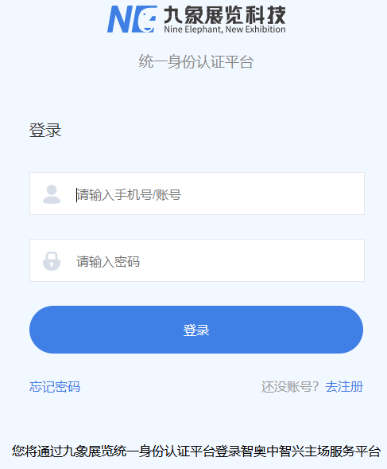

1. **Select Exhibition**

Select the exhibition name in the pop-up layer of the system (you can switch exhibitions at any time at the "Switch Exhibition" section)

1. **Review special booth drawings**

• Click “Review special booth drawings”and click “New application”

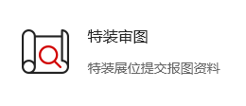

• Fill in basic information

• Click on "Please select images (multiple choices are allowed)" to upload the review data. Multiple documents of the same type can be uploaded simultaneously, and the upload data format only supports image format

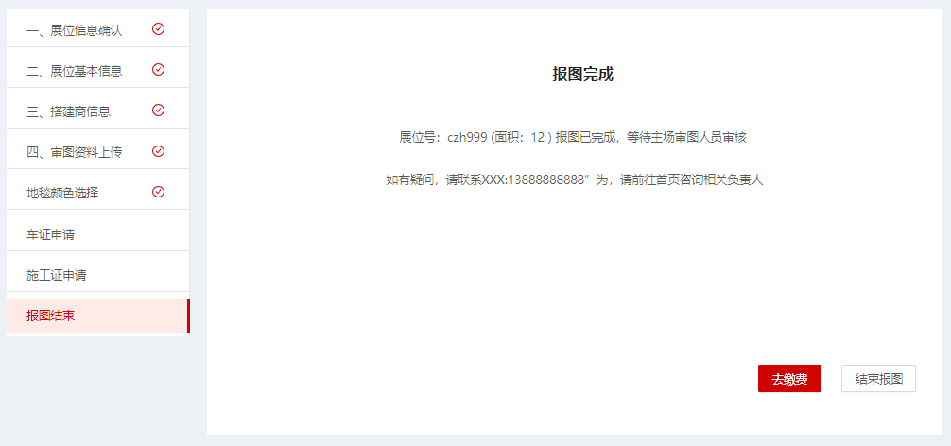

• After completion, 'submit' the review of the drawings (the review results will be notified via email and SMS)

1. **Fixed fee payment**

• click “Fixed fee payment”



• Select the booth number for this operation (multiple choices are allowed), or add a new booth through "Manual Booth Addition"

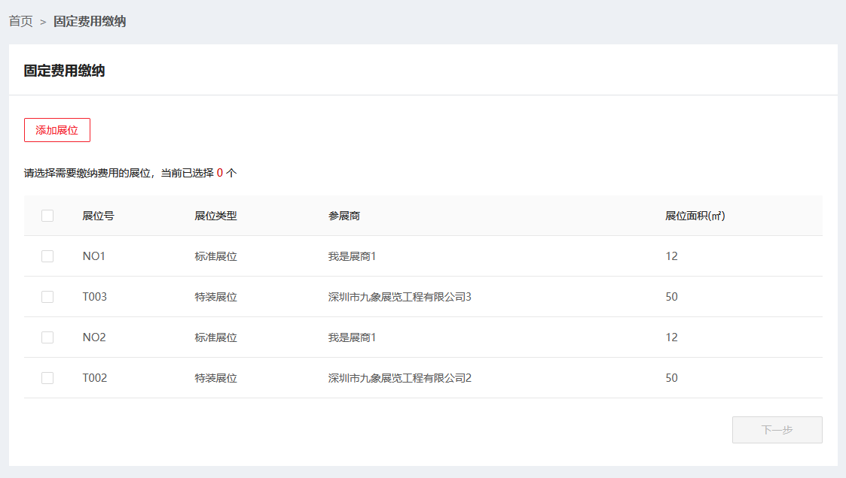

• Check the fixed fee item that needs to be paid to confirm the booth, and if it involves quantity, it can be edited accordingly

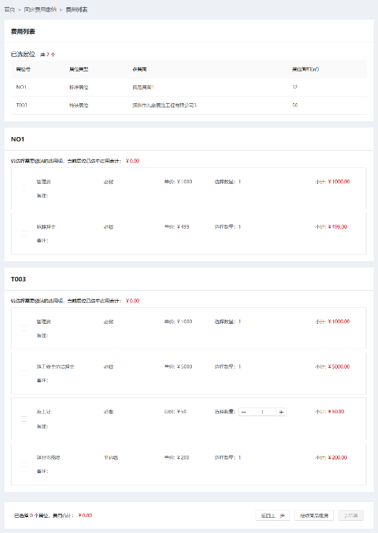

• Click “Next”

1. **Furniture Rental**

• Enter the "Product Rental" page (you can enter through the next step of fixed fee payment, or click on "Product Rental" on the homepage)

• Select the booth number for this operation (single choice)

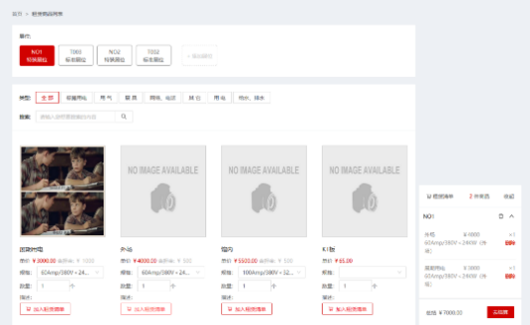

• Add the items that need to be rented to the shopping cart

• Select a new booth number and repeat the above steps to complete product leasing for multiple booths

• Click “Next”

1. **Payment**

• Check the order information. If the information is incorrect, you can return to the "previous step" to adjust or directly remove excess products on the current page

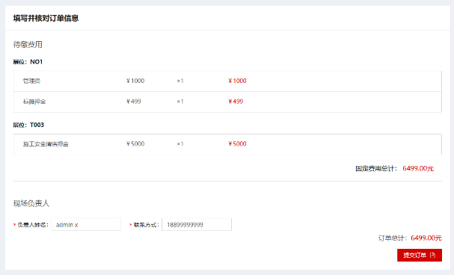

• After confirming that the information is correct, click "Next". If there are any special requirements, fill them in the remarks column and submit the order after completion

• Confirm the payment amount and select the payment method to complete the payment (there are three payment methods: "online payment", "banking wire", "cash/credit card", "Alipay" and "WeChat", which can be selected according to the actual situation)

**7. Invoice Application**

• Click“Invoice Application”

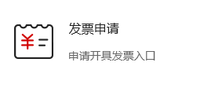

•After reading and confirming the agreement, click 'agree'

• After checking the order or product item that needs to be invoiced this time, choose to apply for "ordinary invoice" or "value-added tax invoice" as needed

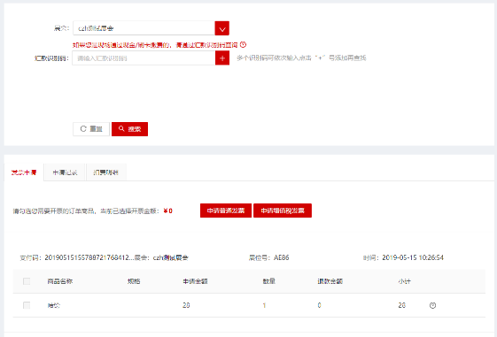

• After filling in the invoice application information and mailing address, click "Submit" to complete the invoice application operation

• If you choose "Apply for value-added tax invoice", complete the invoice information and upload relevant documents as required. After selecting the collection method, click "Submit" to complete the invoice application operation

• The invoice information not seen on the page can be queried through the remittance identification code

• In the "Application Record", you can query the application record and status, or cancel the application

**8. Deposit Refund Application**

• Click“Deposit Refund Application”

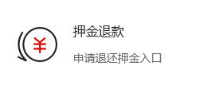

•Select the order number to apply for and click on 'Apply'

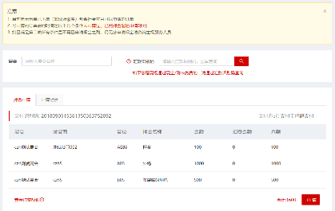

**Notes：**If the booth being applied for is closed, you can enter the exhibition name in the exhibition column to search for the deposit record under that booth. For items not seen on the page, you can enter the "remittance identification code" on the ticket to find them

• After confirming that the deposit information is correct, click on "Apply"

• Fill in the relevant information and upload the required documents, then click on "Deposit Return Application" to submit the deposit application, and complete the deposit application operation

**Please refer to the operation steps for specific functional modules：**

https://www.kancloud.cn/geestu/v002/1071989

|  |
| --- |
| **Designated contractor for the exhibition - GL events live (Shenzhen) Co., Ltd** |
| Contacts：**On-site services (handling entry procedures, renting water, electricity, exhibition equipment, and issuing expense invoices, etc.)**  **Mr.He 0755-81488483-650 /18128860258**  **Review of special decoration drawings and on-site safety management of special decoration**  **Mr.Jiang Tel：19925211325**  **Application website：<http://zhan.zzxes.com.cn>**  Address：14th Floor, Tianjian Entrepreneurship Building, No. 7 Shangbao Road, Futian District, Shenzhen  Tel：0755-81488483 Tax：0755-28153794 |